МИНИСТЕРСТВО НАУКИ И ВЫСШЕГО ОБРАЗОВАНИЯ РФ

ФГБОУ ВО «Брянский государственный технический университет»

Кафедра «Компьютерные технологии и системы»

Направление подготовки

10.05.04- «Информационно-аналитические системы безопасности»

Профиль – «Автоматизация информационно-аналитической деятельности»

**Отчет по лабораторным работам**

по дисциплине: «Численные методы»

|  |  |
| --- | --- |
|  | Выполнили:  Студента группы О-19-ИАС-аид-С  Колотвин Артём Павлович  «_____» ____________ 2022 г |
|  | Принял:  к.т.н., доц. каф. «КТС»  Леонов Юрий Алексеевич  «_____» ____________ 2022 г. |

**Брянск 2022**

## Лабораторная работа №1

### «Решение задач численного дифференцирования»

**Цель работы**: изучение методов численного дифференцирования, вычисление первой и второй производных заданной функции с использованием интерполяционного многочлена Ньютона.

**Скриншоты работы программы**

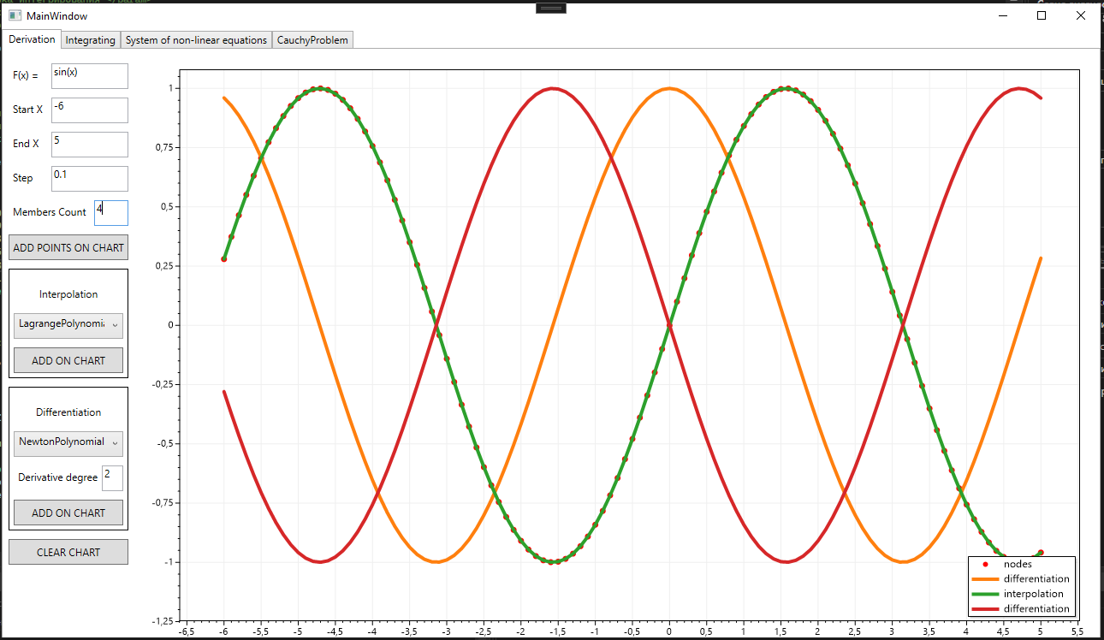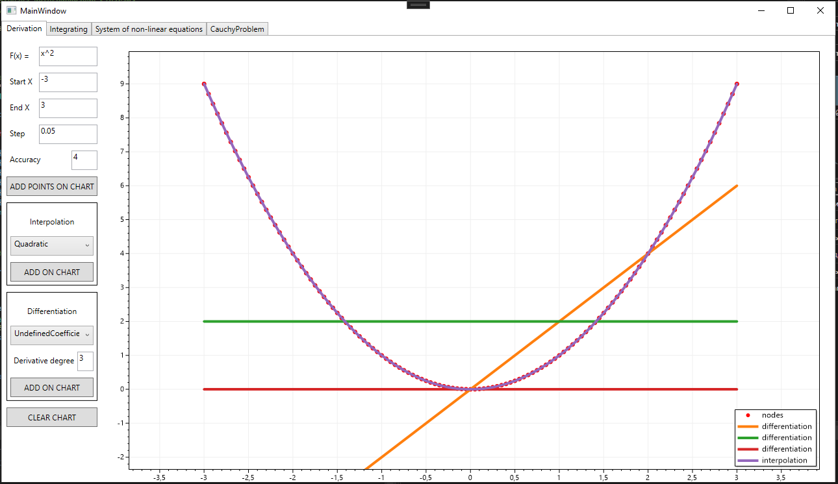

**Структура проекта**

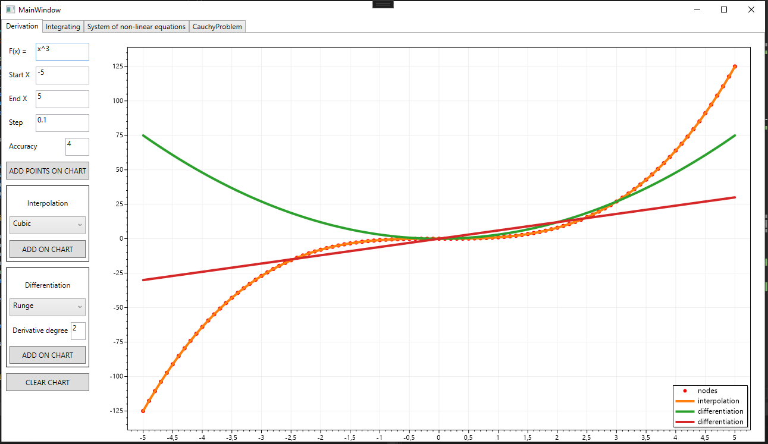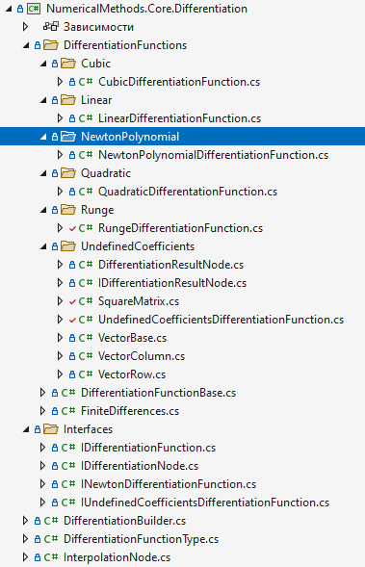

**Листинг программы**

Листинг класса DifferentiationBuilder

using NumericalMethods.Core.Differentiation.Interfaces;

using NumericalMethods.Core.Differentiation.DifferentiationFunctions.Linear;

using NumericalMethods.Core.Differentiation.DifferentiationFunctions.Quadratic;

using NumericalMethods.Core.Differentiation.DifferentiationFunctions.NewtonPolynomial;

using NumericalMethods.Core.Differentiation.DifferentiationFunctions.UndefinedCoefficients;

using NumericalMethods.Core.Differentiation.DifferentiationFunctions.Cubic;

using NumericalMethods.Core.Differentiation.DifferentiationFunctions.Runge;

namespace NumericalMethods.Core.Differentiation;

public static class DifferentiationBuilder

{

public static IDifferentiationFunction? Build(IEnumerable<IDifferentiationNode> differentiation_nodes, DifferentiationFunctionType function_type, double step, int derrivative_degree)

{

return function_type switch

{

DifferentiationFunctionType.Linear => new LinearDifferentiationFunction(differentiation_nodes, step, derrivative_degree),

DifferentiationFunctionType.Quadratic => new QuadraticDifferentationFunction(differentiation_nodes, step, derrivative_degree),

DifferentiationFunctionType.Cubic => new CubicDifferentiationFunction(differentiation_nodes, step, derrivative_degree),

_ => throw new NotImplementedException()

};

}

public static INewtonDifferentiationFunction CreateNewton(IEnumerable<IDifferentiationNode> differentiationNodes, double step, int derivative_degree, int numberOfMembers)

{

return new NewtonPolynomialDifferentiationFunction(differentiationNodes, step, derivative_degree, numberOfMembers);

}

public static IUndefinedCoefficientsDifferentiationFunction CreateUndefinedCoefficients(IEnumerable<IDifferentiationNode> differentiationNodes, double step, int derrivative_degre, int count_coefficients_c)

{

return new UndefinedCoefficientsDifferentiationFunction(differentiationNodes, step, derrivative_degre, count_coefficients_c);

}

public static IDifferentiationFunction CreateRunge(IEnumerable<IDifferentiationNode> differentiationNodes, double step, int derrivative_degre, int accuracy_order, int number_of_used_points)

{

return new RungeDifferentiationFunction(differentiationNodes, step, derrivative_degre, accuracy_order, number_of_used_points);

}

}

Листинг класса DifferentiationFunctionType

namespace NumericalMethods.Core.Differentiation;

public enum DifferentiationFunctionType

{

Linear,

Quadratic,

Cubic,

NewtonPolynomials,

UndefinedCoefficients,

Runge

}

Листинг класса InterpolationNode

using NumericalMethods.Core.Approximation.Interfaces;

namespace NumericalMethods.Core.Differentiation;

public record class InterpolationNode(double X, double Y) : IInterpolationNode;

Листинг класса IDifferentiationFunction

namespace NumericalMethods.Core.Differentiation.Interfaces;

public interface IDifferentiationFunction

{

public double? Calculate(double argument);

}

Листинг класса IDifferentiationNode

namespace NumericalMethods.Core.Differentiation.Interfaces;

public interface IDifferentiationNode

{

public double X { get; init; }

public double Y { get; init; }

}

Листинг класса INewtonDifferentiationFunction

namespace NumericalMethods.Core.Differentiation.Interfaces

{

public interface INewtonDifferentiationFunction

{

public double? Calculate(double argument);

}

}

Листинг класса IUndefinedCoefficientsDifferentiationFunction

using NumericalMethods.Core.Differentiation.DifferentiationFunctions.UndefinedCoefficients;

namespace NumericalMethods.Core.Differentiation.Interfaces;

public interface IUndefinedCoefficientsDifferentiationFunction

{

public IEnumerable<IDifferentiationResultNode> Calculate();

}

Листинг класса DifferentiationFunctionBase

using NumericalMethods.Core.Approximation;

using NumericalMethods.Core.Approximation.Interfaces;

using NumericalMethods.Core.Differentiation.Interfaces;

using NumericalMethods.Core.Differentiation;

namespace NumericalMethods.Core.Differentiation.DifferentiationFunctions

{

internal abstract class DifferentiationFunctionBase

{

protected readonly double _step;

protected readonly int _derivative_degree;

protected readonly IInterpolationFunction _interpolation_function;

protected readonly IDifferentiationNode _center_node;

protected readonly IDifferentiationNode _first_node;

protected readonly IDifferentiationNode _last_node;

protected readonly IEnumerable<IDifferentiationNode> _nodes;

public DifferentiationFunctionBase(IEnumerable<IDifferentiationNode> differentiationNodes, double step, int derrivative_degree)

{

_step = step;

_nodes = differentiationNodes;

_derivative_degree = derrivative_degree;

_first_node = differentiationNodes.First();

_last_node = differentiationNodes.Last();

_center_node = differentiationNodes.OrderBy((node) => node.X).ElementAt(differentiationNodes.Count() / 2);

IEnumerable<IInterpolationNode> mapped_nodes = differentiationNodes.Select(node => new InterpolationNode(node.X, node.Y));

_interpolation_function = InterpolationBuilder.Build(mapped_nodes, InterpolationFunctionType.Cubic);

}

private double? GetCenterFiniteDifference(double argument) => _interpolation_function.Calculate(argument + _step) - _interpolation_function.Calculate(argument - _step);

protected double? GetCenterFiniteDifference(double argument, int degree) => GetCenterFiniteDifferenceRecursive(argument, degree, 1);

private double? GetCenterFiniteDifferenceRecursive(double argument, int degree, int depth)

{

return depth == degree ?

GetCenterFiniteDifference(argument)

: GetCenterFiniteDifferenceRecursive(argument + _step, degree, depth + 1) - GetCenterFiniteDifferenceRecursive(argument - _step, degree, depth + 1);

}

private double? GetLeftFiniteDifference(double argument) => _interpolation_function.Calculate(argument) - _interpolation_function.Calculate(argument - _step);

protected double? GetLeftFiniteDifference(double argument, int degree) => GetLeftFiniteDifferenceRecursive(argument, degree, 1);

private double? GetLeftFiniteDifferenceRecursive(double argument, int degree, int depth)

{

return depth == degree ?

GetLeftFiniteDifference(argument)

: GetLeftFiniteDifferenceRecursive(argument, degree, depth + 1) - GetLeftFiniteDifferenceRecursive(argument - _step, degree, depth + 1);

}

private double? GetRightFiniteDifference(double argument) => _interpolation_function.Calculate(argument + _step) - _interpolation_function.Calculate(argument);

protected double? GetRightFiniteDifference(double argument, int degree) => GetRightFiniteDifferenceRecursive(argument, degree, 1);

private double? GetRightFiniteDifferenceRecursive(double current_argument, int degree, int depth)

{

return depth == degree ?

GetRightFiniteDifference(current_argument)

: GetRightFiniteDifferenceRecursive(current_argument + _step, degree, depth + 1) - GetRightFiniteDifferenceRecursive(current_argument, degree, depth + 1);

}

}

Листинг класса FiniteDifferences

namespace NumericalMethods.Core.Differentiation.DifferentiationFunctions;

public enum FiniteDifferences

{

Left,

Center,

Right

}

Листинг класса LinearDifferentiationFunction

using NumericalMethods.Core.Differentiation.DifferentiationFunctions;

using NumericalMethods.Core.Differentiation.Interfaces;

namespace NumericalMethods.Core.Differentiation.DifferentiationFunctions.Linear;

internal class LinearDifferentiationFunction : DifferentiationFunctionBase, IDifferentiationFunction

{

private readonly INewtonDifferentiationFunction _newton_funtion;

public LinearDifferentiationFunction(IEnumerable<IDifferentiationNode> interpolation_nodes, double step, int derrivative_degree)

: base(interpolation_nodes, step, derrivative_degree)

{

_newton_funtion = DifferentiationBuilder.CreateNewton(interpolation_nodes, step, derrivative_degree, derrivative_degree + 1);

}

public double? Calculate(double argument) => _newton_funtion.Calculate(argument);

}

Листинг класса QuadraticDifferentationFunction

using NumericalMethods.Core.Differentiation;

using NumericalMethods.Core.Differentiation.DifferentiationFunctions;

using NumericalMethods.Core.Differentiation.Interfaces;

namespace NumericalMethods.Core.Differentiation.DifferentiationFunctions.Quadratic;

internal class QuadraticDifferentationFunction : DifferentiationFunctionBase, IDifferentiationFunction

{

private INewtonDifferentiationFunction _newton_function;

public QuadraticDifferentationFunction(IEnumerable<IDifferentiationNode> differentiation_nodes, double step, int derrivative_degree)

: base(differentiation_nodes, step, derrivative_degree)

{

_newton_function = DifferentiationBuilder.CreateNewton(differentiation_nodes, step, derrivative_degree, derrivative_degree + 2);

}

public double? Calculate(double argument) => _newton_function.Calculate(argument);

}

Листинг класса CubicDifferentiationFunction

using NumericalMethods.Core.Differentiation.Interfaces;

namespace NumericalMethods.Core.Differentiation.DifferentiationFunctions.Cubic;

internal class CubicDifferentiationFunction : DifferentiationFunctionBase, IDifferentiationFunction

{

private readonly INewtonDifferentiationFunction _newton_function;

public CubicDifferentiationFunction(IEnumerable<IDifferentiationNode> differentiationNodes, double step, int derrivative_degree)

: base(differentiationNodes, step, derrivative_degree)

{

_newton_function = DifferentiationBuilder.CreateNewton(differentiationNodes, step, derrivative_degree, derrivative_degree + 3);

}

public double? Calculate(double argument) => _newton_function.Calculate(argument);

}

Листинг класса NewtonPolynomialDifferentiationFunction

using MathNet.Symbolics;

using NumericalMethods.Core.Differentiation.DifferentiationFunctions;

using NumericalMethods.Core.Differentiation.Interfaces;

using System.Globalization;

using System.Text;

using System.Text.Json;

using System.Text.RegularExpressions;

namespace NumericalMethods.Core.Differentiation.DifferentiationFunctions.NewtonPolynomial;

internal class NewtonPolynomialDifferentiationFunction : DifferentiationFunctionBase, INewtonDifferentiationFunction

{

private readonly Dictionary<int, int> factorialCache = new Dictionary<int, int>() { { 1, 1 } };

private int _numberOfMembers;

private SymbolicExpression _functionExpression;

private List<string> _other_variables;

private List<int> _degrees;

private readonly double last_x_for_right_finite_difference;

private readonly double first_x_for_left_finite_difference;

public NewtonPolynomialDifferentiationFunction(IEnumerable<IDifferentiationNode> differentiationNodes, double step, int derrivative_degree, int numberOfMembers)

: base(differentiationNodes, step, derrivative_degree)

{

_numberOfMembers = numberOfMembers;

string? function = GetNewtonPolynomialDerrivative(_derivative_degree, _numberOfMembers);

_functionExpression = SymbolicExpression.Parse(function);

_other_variables = _functionExpression

.CollectVariables()

.Select(variable => variable.ToString())

.Where(variable => variable.Contains('y')).ToList();

_degrees = _other_variables

.Select(variable => int.Parse(variable[1..])).ToList();

int max_finite_difference_degree = _numberOfMembers - 1;

last_x_for_right_finite_difference = _first_node.X + step * max_finite_difference_degree;

first_x_for_left_finite_difference = _last_node.X - step * max_finite_difference_degree;

}

private int CalculateFactorial(int value)

{

if (factorialCache.TryGetValue(value, out int cachedValue))

{

return cachedValue;

}

else

{

if (value < 2) return 1;

int calculatedValue = value * CalculateFactorial(value - 1);

factorialCache.Add(value, calculatedValue);

return calculatedValue;

}

}

private string GetNewtonPolynomial(int numberOfMembers)

{

switch (numberOfMembers)

{

case < 2: return "f";

case 2: return "f + t*y1";

default:

{

StringBuilder result = new StringBuilder("f + t*y1");

for (int i = 3; i <= numberOfMembers; i++)

{

int n = i - 1;

int factorial = CalculateFactorial(n);

List<string> bracketsList = new List<string>();

for (int j = 0; j < n - 1; j++)

{

bracketsList.Add($"(t - {j + 1})");

}

string bracketsString = string.Join(" * ", bracketsList);

string member = $"t * {bracketsString}/{factorial}*y{n}";

result.Append($" + {member}");

}

return result.ToString();

}

}

}

private string? GetNewtonPolynomialDerrivative(int derrivativeDegree, int numberOfMembers)

{

if (derrivativeDegree < 1 || derrivativeDegree + 1 > numberOfMembers) return null;

string newtonPolynomial = GetNewtonPolynomial(numberOfMembers);

SymbolicExpression result = SymbolicExpression.Parse(newtonPolynomial).Expand();

for (int i = 0; i < derrivativeDegree; i++)

{

result = result.Differentiate("t");

}

return result.ToString();

}

public double? Calculate(double argument)

{

List<double?> variablesValues = new List<double?>();

FiniteDifferences difference_type = ChoiceDifference(argument);

double t_value = 1;

double denominator = 1;

switch (difference_type)

{

case FiniteDifferences.Right:

variablesValues = _degrees.Select(finiteDifferenceDegree => GetRightFiniteDifference(argument, finiteDifferenceDegree)).ToList();

t_value = 0;

denominator = Math.Pow(_step, _derivative_degree);

break;

case FiniteDifferences.Left:

variablesValues = _degrees.Select(finiteDifferenceDegree => GetLeftFiniteDifference(argument, finiteDifferenceDegree)).ToList();

t_value = 1;

denominator = Math.Pow(_step, _derivative_degree);

break;

case FiniteDifferences.Center:

variablesValues = _degrees.Select(finiteDifferenceDegree => GetCenterFiniteDifference(argument, finiteDifferenceDegree)).ToList();

t_value = 1;

denominator = Math.Pow(2 * _step, _derivative_degree);

break;

};

if (variablesValues.Any(variableValue => variableValue is null)) return null;

Dictionary<string, FloatingPoint> values = new Dictionary<string, FloatingPoint>()

{

{"t", t_value }

};

for (int i = 0; i < _other_variables.Count; i++)

{

values.Add(_other_variables[i], variablesValues[i]);

}

return _functionExpression.Evaluate(values).RealValue / denominator;

}

private FiniteDifferences ChoiceDifference(double argument)

{

if (argument <= last_x_for_right_finite_difference) return FiniteDifferences.Right;

else if (argument >= first_x_for_left_finite_difference) return FiniteDifferences.Left;

else return FiniteDifferences.Center;

}

}

Листинг класса UndefinedCoefficientsDifferentiationFunction

using MathNet.Symbolics;

using NumericalMethods.Core.Differentiation.Interfaces;

namespace NumericalMethods.Core.Differentiation.DifferentiationFunctions.UndefinedCoefficients

{

internal class UndefinedCoefficientsDifferentiationFunction : DifferentiationFunctionBase, IUndefinedCoefficientsDifferentiationFunction

{

private readonly int _count_coefficients_c;

SymbolicExpression[] _ys_before_last_derivative_expressions;

SymbolicExpression[] _ys_last_derivative_expressions;

private double[] _current_xs;

private double[] _current_ys;

public UndefinedCoefficientsDifferentiationFunction(IEnumerable<IDifferentiationNode> differentiationNodes, double step, int derrivative_degree, int count_coefficients_c)

: base(differentiationNodes, step, derrivative_degree)

{

_count_coefficients_c = count_coefficients_c;

_current_xs = differentiationNodes.Select(node => node.X).ToArray();

_current_ys = differentiationNodes.Select(node => node.Y).ToArray();

_ys_before_last_derivative_expressions = new SymbolicExpression[_count_coefficients_c];

_ys_last_derivative_expressions = new SymbolicExpression[_count_coefficients_c];

for (int i = 0; i < _count_coefficients_c; i++)

{

_ys_before_last_derivative_expressions[i] = $"(x - x0)^{i}";

}

_ys_last_derivative_expressions = _ys_before_last_derivative_expressions.Select(y => y.Differentiate("x")).ToArray();

}

public IEnumerable<IDifferentiationResultNode> Calculate()

{

for (int i = 0; i < _derivative_degree; i++)

{

List<double> cs = SolveLinearSystem().ToList();

int start_new_items_index = 1;

int end_new_items_index = _current_xs.Length - (_count_coefficients_c - 2);

double[] new_ys = new double[end_new_items_index];

double[] new_xs = _current_xs[start_new_items_index..end_new_items_index];

for (int j = start_new_items_index; j < end_new_items_index; j++)

{

new_ys[j - 1] = _current_ys[(j - 1)..(j - 1 + _count_coefficients_c)].Zip(cs, (y, c) => y * c).Sum();

}

_current_xs = new_xs;

_current_ys = new_ys;

}

return _current_xs.Zip(_current_ys, (x, y) => new DifferentiationResultNode(x, y));

}

private VectorColumn SolveLinearSystem()

{

SquareMatrix matrix = CreateMatrix();

VectorColumn vectorB = CreateVectorB();

SquareMatrix invertedMatrix = matrix.Invert();

return invertedMatrix * vectorB;

}

private VectorColumn CreateVectorB()

{

IDictionary<string, FloatingPoint> values = new Dictionary<string, FloatingPoint>()

{

{ "x", _current_xs[1] },

{ "x0", _current_xs[0] }

};

double[] vectorBody = _ys_last_derivative_expressions

.Select((yExpression, index) => yExpression.Evaluate(values).RealValue)

.ToArray();

return new VectorColumn(vectorBody);

}

private SquareMatrix CreateMatrix()

{

double[,] matrixBody = new double[_count_coefficients_c, _count_coefficients_c];

for (int i = 0; i < _count_coefficients_c; i++)

{

for (int j = 0; j < _count_coefficients_c; j++)

{

IDictionary<string, FloatingPoint> values = new Dictionary<string, FloatingPoint>()

{

{ "x", _current_xs[j] },

{ "x0", _current_xs[0] }

};

matrixBody[i, j] = _ys_before_last_derivative_expressions[i].Evaluate(values).RealValue;

}

}

return new SquareMatrix(matrixBody);

}

}

}

Листинг класса RungeDifferentiationFunction

using NumericalMethods.Core.Differentiation.Interfaces;

namespace NumericalMethods.Core.Differentiation.DifferentiationFunctions.Runge

{

internal class RungeDifferentiationFunction : DifferentiationFunctionBase, IDifferentiationFunction

{

private readonly int _accuracy_order;

private readonly int _number_of_used_points;

public RungeDifferentiationFunction(IEnumerable<IDifferentiationNode> differentiationNodes, double step, int derrivative_degree, int accuracy_order, int number_of_used_points)

: base(differentiationNodes, step, derrivative_degree)

{

_accuracy_order = accuracy_order;

_number_of_used_points = number_of_used_points;

}

public double? Calculate(double argument)

{

return CalculateRecursive(argument, 1);

}

private double? CalculateRecursive(double argument,int depth)

{

Func<double, double?> f = _interpolation_function.Calculate;

double? xh = (f(argument) - f(argument - _step)) / _step;

double? xkh = (f(argument) - f(argument - _step * _number_of_used_points)) / (_step * _number_of_used_points);

if (xh == null || xkh == null)

{

xh = (f(argument + _step) - f(argument)) / _step;

xkh = (f(argument + _step * _number_of_used_points) - f(argument)) / (_step * _number_of_used_points);

}

int new_depth = depth + 1;

if(depth != _derivative_degree)

{

xh = (CalculateRecursive(argument, new_depth) - CalculateRecursive(argument - _step, new_depth)) / _step;

xkh = (CalculateRecursive(argument, new_depth) - CalculateRecursive(argument - _step * _number_of_used_points, new_depth)) / (_step * _number_of_used_points);

if (xh == null || xkh == null)

{

xh = (CalculateRecursive(argument+_step,new_depth) - CalculateRecursive(argument,new_depth)) / _step;

xkh = (CalculateRecursive(argument + _step * _number_of_used_points,new_depth) - CalculateRecursive(argument, new_depth)) / (_step * _number_of_used_points);

}

}

return xh + (xh - xkh) / (Math.Pow(_number_of_used_points, _accuracy_order) - 1);

}

}

}

Листинг класса IDifferentiationResultNode

namespace NumericalMethods.Core.Differentiation.DifferentiationFunctions.UndefinedCoefficients;

public interface IDifferentiationResultNode

{

public double X { get; init; }

public double Y { get; init; }

}

Листинг класса DifferentiationResultNode

namespace NumericalMethods.Core.Differentiation.DifferentiationFunctions.UndefinedCoefficients;

public record class DifferentiationResultNode(double X, double Y) : IDifferentiationResultNode;

Листинг класса SquareMatrix

using MathNet.Symbolics;

namespace NumericalMethods.Core.Differentiation.DifferentiationFunctions.UndefinedCoefficients;

public class SquareMatrix

{

private readonly double[,] _data;

public int Size { get; set; }

public SquareMatrix(int size)

{

_data = new double[size, size];

Size = size;

}

public SquareMatrix(double[,] data)

{

Size = data.GetLength(0);

_data = new double[Size, Size];

FillDataFrom(data);

}

public double this[int row, int col]

{

get

{

return row >= 0 && row < _data.GetLength(0) && col >= 0 && col < _data.GetLength(1)

? _data[row, col]

: throw new ArgumentOutOfRangeException("row or col invalid");

}

set

{

_data[row, col] = row >= 0 && row < _data.GetLength(0) && col >= 0 && col < _data.GetLength(1)

? value

: throw new ArgumentOutOfRangeException("row or col invalid");

}

}

public static VectorColumn operator * (SquareMatrix matrix, VectorColumn vector)

{

VectorColumn result = new VectorColumn(vector.Size);

for (int i = 0; i < matrix.Size; i++)

{

double row_sum = 0;

for (int j = 0; j < matrix.Size; j++)

{

row_sum += matrix[i, j] * vector[j];

}

result[i] = row_sum;

}

return result;

}

public static SquareMatrix operator - (SquareMatrix matrix)

{

for (int i = 0; i < matrix.Size; i++)

{

for (int j = 0; j < matrix.Size; j++)

{

matrix[i, j] = -matrix[i, j];

}

}

return matrix;

}

private void FillDataFrom(double[,] data)

{

for (int i = 0; i < Size; i++)

{

for (int j = 0; j < Size; j++)

{

this[i, j] = data[i, j];

}

}

}

/// <summary> Вычисляет норму матрицы </summary>

public double GetNorm()

{

double max = 0;

for (int i = 0; i < Size; i++)

{

double row_sum = 0;

for (int j = 0; j < Size; j++)

{

row_sum += Math.Abs(this[i, j]);

}

if (row_sum > max) max = row_sum;

}

return max;

}

/// <summary> Вычисляет определитель матрицы </summary>

public double GetDeterminant()

{

int size = _data.GetLength(0);

switch (size)

{

case 1: return _data[0, 0];

case 2: return (_data[0, 0] * _data[1, 1]) - (_data[1, 0] * _data[0, 1]);

default:

double determinant = 0;

for (int column = 0; column < size; column++)

{

determinant += (column % 2 == 0 ? 1 : -1) * _data[0, column] * CreateMatrixWithoutRowAndColumn(0, column).GetDeterminant();

}

return determinant;

}

}

/// <summary> Создает урезанную матрицу </summary>

/// <param name="index_row">Удаляемая строка</param>

/// <param name="index_column">Удаляемый столбец</param>

/// <returns>Новая урезанная матрица</returns>

public SquareMatrix CreateMatrixWithoutRowAndColumn(int index_row, int index_column)

{

SquareMatrix new_matrix = new SquareMatrix(Size - 1);

List<List<double>> elements_new_matrix = new List<List<double>>();

for (int i = 0; i < this.Size; i++)

{

if (i == index_row) continue;

elements_new_matrix.Add(new List<double>());

for (int j = 0; j < this.Size; j++)

{

if (j == index_column) continue;

elements_new_matrix.Last().Add(this[i, j]);

}

}

for (int i = 0; i < new_matrix.Size; i++)

{

for (int j = 0; j < new_matrix.Size; j++)

{

new_matrix[i, j] = elements_new_matrix[i][j];

}

}

return new_matrix;

}

/// <summary> Инвертирует текущую матрицу</summary>

public SquareMatrix Invert()

{

double determinant = this.GetDeterminant();

SquareMatrix transposed = this.CreateAlgebraicAddition().Transpose();

for (int i = 0; i < Size; i++)

{

for (int j = 0; j < Size; j++)

{

this[i, j] = transposed[i, j] / determinant;

}

}

return this;

}

/// <summary> Создает алгебраическое дополнение </summary>

/// <returns>Новая матрица - алгебраическое дополнение текущей</returns>

public SquareMatrix CreateAlgebraicAddition()

{

SquareMatrix algebraic_addition_matrix = new SquareMatrix(Size);

for (int i = 0; i < Size; i++)

{

for (int j = 0; j < Size; j++)

{

algebraic_addition_matrix[i, j] = ((i + j) % 2 is 0 ? 1 : -1) * CreateMatrixWithoutRowAndColumn(i, j).GetDeterminant();

}

}

return algebraic_addition_matrix;

}

/// <summary> Транспонирует текущую матрицу </summary>

public SquareMatrix Transpose()

{

double[,] new_data = new double[Size, Size];

for (int i = 0; i < Size; i++)

{

for (int j = 0; j < Size; j++)

{

new_data[i, j] = this[j, i];

}

}

FillDataFrom(new_data);

return this;

}

/// <summary> Создает матрицу Якоби </summary>

public static SquareMatrix CreateJacobiMatrix(IEnumerable<SymbolicExpression> functions, Dictionary<string, FloatingPoint> values)

{

var variables = functions.First().CollectVariables();

int count_params = variables.Count();

SquareMatrix resultMatrix = new SquareMatrix(count_params);

for (int i = 0; i < resultMatrix.Size; i++)

{

for (int j = 0; j < resultMatrix.Size; j++)

{

string currentVariableName = variables.ElementAt(j).ToString();

resultMatrix[i, j] = functions.ElementAt(i)

.Differentiate(variables.ElementAt(j))

.Evaluate(values).RealValue;

}

}

return resultMatrix;

}

}

Листинг класса VectorBase

namespace NumericalMethods.Core.Differentiation.DifferentiationFunctions.UndefinedCoefficients;

public abstract class VectorBase

{

private readonly double[] _data;

public VectorBase(double[] data)

{

_data = data;

}

public VectorBase(int size)

{

_data = new double[size];

}

public double this[int index]

{

get => _data[index];

set => _data[index] = value;

}

public double GetNormM()

{

return _data.Select(vector => Math.Abs(vector)).Max();

}

public List<double> ToList()

{

return _data.ToList();

}

public int Size { get => _data.Length; }

}

Листинг класса VectorColumn

namespace NumericalMethods.Core.Differentiation.DifferentiationFunctions.UndefinedCoefficients

{

public class VectorColumn : VectorBase

{

public VectorColumn(int size) : base(size)

{

}

public VectorColumn(double[] data) : base(data)

{

}

public static VectorColumn operator -(VectorColumn vector)

{

for (int i = 0; i < vector.Size; i++)

{

vector[i] = -vector[i];

}

return vector;

}

public static VectorColumn operator +(VectorColumn vectorOne, VectorColumn vectorTwo)

{

if (vectorOne.Size > vectorTwo.Size)

{

VectorColumn result = new VectorColumn(vectorOne.Size);

for (int i = 0; i < vectorTwo.Size; i++)

{

result[i] = vectorOne[i] + vectorTwo[i];

}

for (int i = vectorTwo.Size; i < result.Size; i++)

{

result[i] = vectorOne[i];

}

return result;

} else

{

VectorColumn result = new VectorColumn(vectorTwo.Size);

for (int i = 0; i < vectorOne.Size; i++)

{

result[i] = vectorOne[i] + vectorTwo[i];

}

for (int i = vectorOne.Size; i < result.Size; i++)

{

result[i] = vectorTwo[i];

}

return result;

}

}

public static VectorColumn operator -(VectorColumn vectorOne, VectorColumn vectorTwo)

{

return vectorOne + -vectorTwo;

}

}

}

Листинг класса VectorRow

namespace NumericalMethods.Core.Differentiation.DifferentiationFunctions.UndefinedCoefficients;

public class VectorRow : VectorBase

{

public VectorRow(int size) : base(size)

{

}

public VectorRow(double[] data) : base(data)

{

}

}

Листинг класса MainWindow.xaml

using NumericalMethods.Core.Approximation;

using NumericalMethods.Core.Approximation.Interfaces;

using NumericalMethods.Core.Differentiation;

using NumericalMethods.Core.Differentiation.DifferentiationFunctions.UndefinedCoefficients;

using NumericalMethods.Core.Differentiation.Interfaces;

using NumericalMethods.Infrastructure.Integration;

using NumericalMethods.Infrastructure.Integration.Interfaces;

using NumericalMethods.Infrastructure.NonLinearEquationsSystems;

using NumericalMethods.Core.CauchyProblem;

using NumericalMethods.Infrastructure.NonLinearEquationsSystems.Methods;

using org.mariuszgromada.math.mxparser;

using ScottPlot;

using System;

using System.Collections.Generic;

using System.Data;

using System.Drawing;

using System.Linq;

using System.Text;

using System.Threading.Tasks;

using System.Windows;

using System.Windows.Controls;

using System.Windows.Input;

using Expression = org.mariuszgromada.math.mxparser.Expression;

using Point = NumericalMethods.WPFApplication.Differentiation.Point;

namespace NumericalMethods.WPFApplication

{

/// <summary>

/// Interaction logic for MainWindow.xaml

/// </summary>

public partial class MainWindow : Window

{

private readonly List<Point> _points = new List<Point>();

private Function _current_function;

private double _start_x;

private double _end_x;

private double _step;

private int _order;

private ResultTable _resultTable;

public MainWindow()

{

InitializeComponent();

Width = 1300;

Height = 750;

InitializeDifferentiation();

}

private void InitializeDifferentiation()

{

foreach (var item in Enum.GetValues(typeof(InterpolationFunctionType)))

{

Differentiation_InterpolationFunctionTypeComboBox.Items.Add(item.ToString());

}

Differentiation_InterpolationFunctionTypeComboBox.SelectedItem = Differentiation_InterpolationFunctionTypeComboBox.Items[0];

foreach (var item in Enum.GetValues(typeof(DifferentiationFunctionType)))

{

Differentiation_FunctionTypeComboBox.Items.Add(item.ToString());

}

Differentiation_FunctionTypeComboBox.SelectedItem = Differentiation_InterpolationFunctionTypeComboBox.Items[0];

Differentiation_FunctionTextBox.Text = "x^2";

Differentiation_StartXTextBox.Text = "-3";

Differentiation_EndXTextBox.Text = "3";

Differentiation_StepTextBox.Text = "1";

Differentiation_NumberOfMembers.Text = "2";

DerivativeDegreeTextBox.Text = "1";

Differentiation_MainChart.Plot.Legend(enable: true);

}

private void Differentiation_AddNodesOnChart_Click(object sender, RoutedEventArgs e)

{

if (String.IsNullOrEmpty(Differentiation_FunctionTextBox.Text) ||

String.IsNullOrEmpty(Differentiation_StartXTextBox.Text) ||

String.IsNullOrEmpty(Differentiation_EndXTextBox.Text) ||

String.IsNullOrEmpty(Differentiation_StepTextBox.Text))

{

MessageBox.Show("Для начала рассчёта, заполните все поля");

return;

}

_points.Clear();

_current_function = new Function("f(x) = " + Differentiation_FunctionTextBox.Text.Trim());

double start_x = new Expression(Differentiation_StartXTextBox.Text.Trim()).calculate();

double end_x = new Expression(Differentiation_EndXTextBox.Text.Trim()).calculate();

double step = new Expression(Differentiation_StepTextBox.Text.Trim()).calculate();

int roundNumbers = step.ToString().Contains(',') ? step.ToString().Split(',')[1].Length % 16 : 1;

for (double x = start_x; Math.Round(x, roundNumbers) <= end_x; x += step)

{

double y = _current_function.calculate(x);

_points.Add(new Point(x, y));

}

double[] xs = _points.Select(node => node.X).ToArray();

double[] ys = _points.Select(node => node.Y).ToArray();

Differentiation_MainChart.Plot.AddScatter(xs, ys, lineWidth: 0, markerShape: MarkerShape.filledCircle, color: System.Drawing.Color.Red, markerSize: 7, label: "nodes");

Differentiation_MainChart.Refresh();

}

private void Differentiation_FunctionTypeComboBox_SelectionChanged(object sender, SelectionChangedEventArgs e)

{

Differentiation_AccuracyGrid.Visibility = Visibility.Collapsed;

Differentiation_NumberOfMembersGrid.Visibility = Visibility.Collapsed;

Differentiation_Accuracy.Text = "";

Differentiation_NumberOfMembers.Text = "";

DifferentiationFunctionType differentiationFunctionType = (DifferentiationFunctionType)Enum.Parse(typeof(DifferentiationFunctionType), ((ComboBox)sender).SelectedValue.ToString());

if(differentiationFunctionType == DifferentiationFunctionType.NewtonPolynomials)

{

Differentiation_NumberOfMembersGrid.Visibility = Visibility.Visible;

}

if(differentiationFunctionType == DifferentiationFunctionType.Runge || differentiationFunctionType == DifferentiationFunctionType.UndefinedCoefficients)

{

Differentiation_AccuracyGrid.Visibility = Visibility.Visible;

}

}

private void Differentiation_AddOnChartInterpolationButton_Click(object sender, RoutedEventArgs e)

{

if(_points.Count == 0)

{

MessageBox.Show("Добавьте точки");

return;

}

string? function_type_string = Differentiation_InterpolationFunctionTypeComboBox.SelectedValue.ToString();

if (function_type_string is null) return;

InterpolationFunctionType interpolation_type = Enum.Parse<InterpolationFunctionType>(function_type_string);

IInterpolationFunction? interpolation_function = InterpolationBuilder.Build(_points, interpolation_type);

if (interpolation_function is null) return;

var xs = new List<double>();

var ys = new List<double>();

double start_x = new Expression(Differentiation_StartXTextBox.Text.Trim()).calculate();

double end_x = new Expression(Differentiation_EndXTextBox.Text.Trim()).calculate();

double step = new Expression(Differentiation_StepTextBox.Text.Trim()).calculate();

int roundNumbers = step.ToString().Contains(',') ? step.ToString().Split(',')[1].Length % 16 : 1;

for (double x = start_x; Math.Round(x, roundNumbers) <= end_x; x += step)

{

var y = interpolation_function.Calculate(x);

if (y is null) continue;

xs.Add(x);

ys.Add((double)y);

}

Differentiation_MainChart.Plot.AddScatter(xs.ToArray(), ys.ToArray(), lineWidth: 4, markerSize: 0, label: "interpolation");

Differentiation_MainChart.Refresh();

Differentiation_MainChart.Refresh();

}

private void Differentiation_AddOnChartButton_Click(object sender, RoutedEventArgs e)

{

if (_points.Count == 0)

{

MessageBox.Show("Добавьте точки");

return;

}

var xs = new List<double>();

var ys = new List<double>();

_start_x = new Expression(Differentiation_StartXTextBox.Text.Trim()).calculate();

_end_x = new Expression(Differentiation_EndXTextBox.Text.Trim()).calculate();

_step = new Expression(Differentiation_StepTextBox.Text.Trim()).calculate();

int roundNumbers = _step.ToString().Contains(',') ? _step.ToString().Split(',')[1].Length % 16 : 1;

int derivative_degree = int.Parse(DerivativeDegreeTextBox.Text.Trim());

string? function_type_string = Differentiation_FunctionTypeComboBox.SelectedValue.ToString();

if (function_type_string is null) return;

DifferentiationFunctionType interpolation_type = (DifferentiationFunctionType)Enum.Parse(typeof(DifferentiationFunctionType), function_type_string);

switch (interpolation_type)

{

case DifferentiationFunctionType.NewtonPolynomials:

if (String.IsNullOrEmpty(Differentiation_NumberOfMembers.Text))

{

MessageBox.Show("Введите number of members");

return;

}

int numberOfMembers = int.Parse(Differentiation_NumberOfMembers.Text);

INewtonDifferentiationFunction newton_function = DifferentiationBuilder.CreateNewton(_points, _step, derivative_degree, numberOfMembers);

for (double x = _start_x; Math.Round(x, roundNumbers) <= _end_x; x += _step)

{

double? y = newton_function.Calculate(x);

if (y is null) continue;

xs.Add(x);

ys.Add((double)y);

}

break;

case DifferentiationFunctionType.UndefinedCoefficients:

if (String.IsNullOrEmpty(Differentiation_Accuracy.Text))

{

MessageBox.Show("Введите accuracy");

return;

}

int count_coefficients_c = int.Parse(Differentiation_Accuracy.Text);

List<Point> additional_right_points = new List<Point>();

for (int i = 1; i <= (count_coefficients_c - 2) * derivative_degree; i++)

{

double new_x = _end_x + _step * i;

double new_y = _current_function.calculate(new_x);

Point additional_point = new Point(new_x, new_y);

additional_right_points.Add(additional_point);

}

List<Point> additional_left_point = new List<Point>();

for (int i = derivative_degree; i >= 1; i--)

{

double new_x = _start_x - _step * i;

double new_y = _current_function.calculate(new_x);

Point additional_point = new Point(new_x, new_y);

additional_left_point.Add(additional_point);

}

IEnumerable<Point> new_points = additional_left_point.Concat(_points.Concat(additional_right_points));

IUndefinedCoefficientsDifferentiationFunction undefined_coefficients_function = DifferentiationBuilder.CreateUndefinedCoefficients(new_points, _step, derivative_degree, count_coefficients_c);

IEnumerable<IDifferentiationResultNode> result = undefined_coefficients_function.Calculate();

xs = result.Select(node => node.X).ToList();

ys = result.Select(node => node.Y).ToList();

break;

case DifferentiationFunctionType.Runge:

{

if (String.IsNullOrEmpty(Differentiation_Accuracy.Text))

{

MessageBox.Show("Введите accuracy");

return;

}

IDifferentiationFunction differentiation_function = DifferentiationBuilder.CreateRunge(_points, _step, derivative_degree, 1, 2);

for (double x = _start_x; Math.Round(x, roundNumbers) <= _end_x; x += _step)

{

double? y = differentiation_function.Calculate(x);

if (y is null) continue;

xs.Add(x);

ys.Add((double)y);

}

break;

}

default:

{

IDifferentiationFunction differentiation_function = DifferentiationBuilder.Build(_points, interpolation_type, _step, derivative_degree);

for (double x = _start_x; Math.Round(x, roundNumbers) <= _end_x; x += _step)

{

double? y = differentiation_function.Calculate(x);

if (y is null) continue;

xs.Add(x);

ys.Add((double)y);

}

break;

}

}

Differentiation_MainChart.Plot.AddScatter(xs.ToArray(), ys.ToArray(), lineWidth: 4, markerSize: 0, label: "differentiation");

Differentiation_MainChart.Refresh();

}

private void Differentiation_ClearChartButton_Click(object sender, RoutedEventArgs e)

{

Differentiation_MainChart.Plot.Clear();

Differentiation_MainChart.Refresh();

}

}

}

**Вывод:** в ходе выполнения лабораторной работы были изучены методы численного дифференцирования, вычисление первой и второй производных заданной функции с использованием интерполяционного многочлена Ньютона.

## Лабораторная работа №2

### «Решение систем нелинейных уравнений»

**Цель работы**: программная реализация методов решения систем нелинейных уравнений: метод простых итераций, метод Зейделя, метод Ньютона, модифицированный метод Ньютона, метод секущих.

**Скриншоты работы программы**

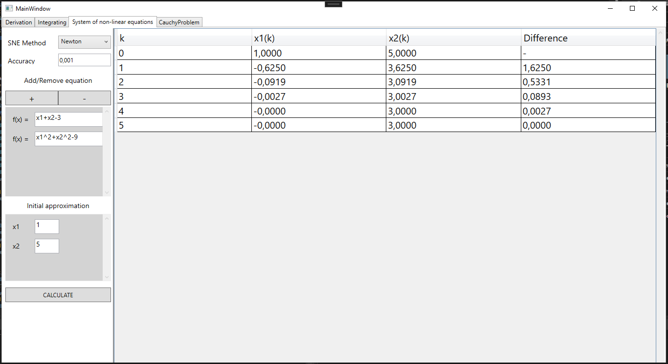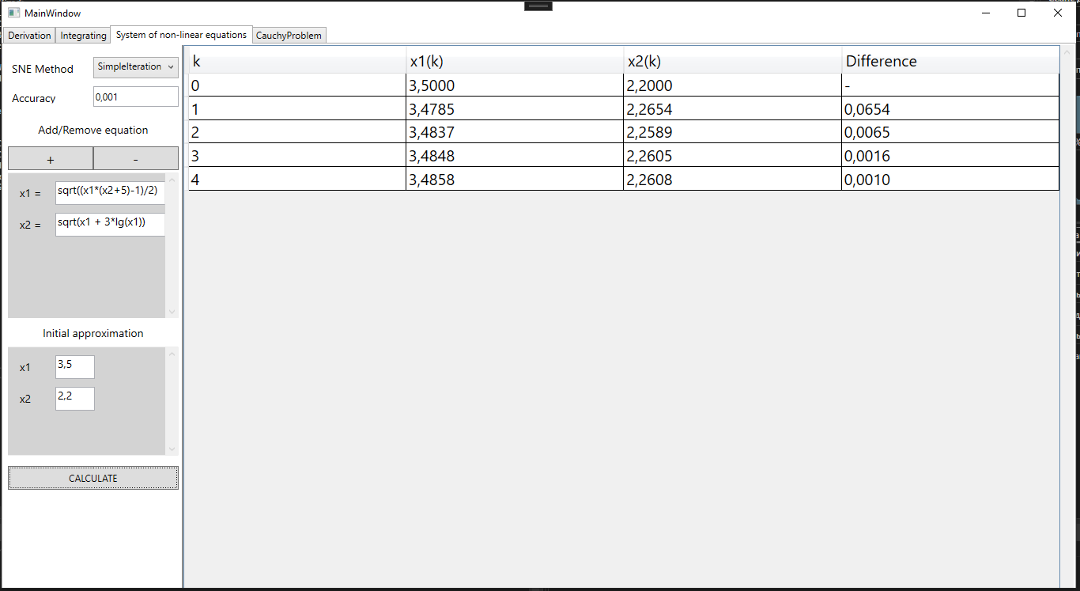

**Структура проекта**

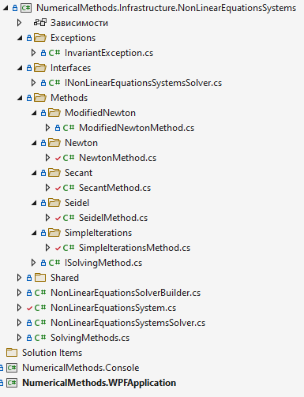

**Листинг работы программы**

Листинг класса ISolvingMethod

using MathNet.Symbolics;

namespace NumericalMethods.Infrastructure.NonLinearEquationsSystems.Methods;

public interface ISolvingMethod

{

public IEnumerable<IEnumerable<double>> SolveWithSteps(NonLinearEquationsSystem system, double eps, Dictionary<string,FloatingPoint> initialGuess);

}

Листинг класса SimpleIterationsMethod

using MathNet.Symbolics;

using NumericalMethods.Infrastructure.NonLinearEquationsSystems.Shared;

namespace NumericalMethods.Infrastructure.NonLinearEquationsSystems.Methods.SimpleIterations

{

public class SimpleIterationsMethod : ISolvingMethod

{

private List<SymbolicExpression> functionExpressions;

private double eps;

private Dictionary<string, FloatingPoint> currentValues;

private List<double> differences;

public IEnumerable<IEnumerable<double>> SolveWithSteps(NonLinearEquationsSystem system, double eps, Dictionary<string,FloatingPoint> initialGuess)

{

Dictionary<string, FloatingPoint> sortedInitialGuess = initialGuess.OrderBy(x => x.Key).ToDictionary(el => el.Key, el => el.Value);

if (Math.Abs(SquareMatrix.CreateJacobiMatrix(system.FunctionExpressions,initialGuess).GetNorm()) >= 1)

throw new Exception("Данное приближение не подходит под условие сходимости попробуйте дургое");

this.currentValues = sortedInitialGuess;

this.functionExpressions = system.FunctionExpressions.ToList();

this.eps = eps;

differences = new List<double>() { double.MinValue };

List<List<double>> results = (List<List<double>>)SolveRecursive(new List<List<double>>() { sortedInitialGuess.Select(el=> el.Value.RealValue).ToList() });

for(int i = 0; i < results.Count; i++)

{

results[i].Add(differences[i]);

}

return results;

}

private IEnumerable<IEnumerable<double>> SolveRecursive(List<List<double>> results)

{

for (int i = 0; i < results.Last().Count; i++)

currentValues[currentValues.ElementAt(i).Key] = results.Last()[i];

results.Add(new List<double>());

functionExpressions.ForEach((functionExpression) => results.Last().Add(functionExpression.Evaluate(currentValues).RealValue));

differences.Add(FindMaxDifference(results.ElementAt(results.Count - 1), results.ElementAt(results.Count - 2)));

if (differences.Last() > eps){

results = (List<List<double>>)SolveRecursive(results);

}

return results;

}

private double FindMaxDifference(List<double> nextValues, List<double> currentValues)

{

return nextValues.Zip(currentValues, (nextValue, currentValue) =>

{

return Math.Abs(nextValue - currentValue);

}).Max();

}

}

}

Листинг класса SeidelMethod

using MathNet.Symbolics;

using NumericalMethods.Infrastructure.NonLinearEquationsSystems.Shared;

namespace NumericalMethods.Infrastructure.NonLinearEquationsSystems.Methods.Seidel

{

internal class SeidelMethod : ISolvingMethod

{

private List<SymbolicExpression> functionExpressions;

private double eps;

private Dictionary<string, FloatingPoint> currentValues;

private List<double> differences;

public IEnumerable<IEnumerable<double>> SolveWithSteps(NonLinearEquationsSystem system, double eps, Dictionary<string, FloatingPoint> initialGuess)

{

Dictionary<string, FloatingPoint> sortedInitialGuess = initialGuess.OrderBy(x => x.Key).ToDictionary(el => el.Key, el => el.Value);

if (Math.Abs(SquareMatrix.CreateJacobiMatrix(system.FunctionExpressions, initialGuess).GetNorm()) >= 1)

throw new Exception("Данное приближение не подходит под условие сходимости попробуйте дургое");

this.currentValues = sortedInitialGuess;

this.functionExpressions = system.FunctionExpressions.ToList();

this.eps = eps;

differences = new List<double>() { double.MinValue };

List<List<double>> results = (List<List<double>>)SolveRecursive(new List<List<double>>() { sortedInitialGuess.Select(el => el.Value.RealValue).ToList() });

for (int i = 0; i < results.Count; i++)

{

results[i].Add(differences[i]);

}

return results;

}

private IEnumerable<IEnumerable<double>> SolveRecursive(List<List<double>> results)

{

for (int i = 0; i < results.Last().Count; i++)

currentValues[currentValues.ElementAt(i).Key] = results.Last()[i];

results.Add(new List<double>());

int countFunctionExpressions = functionExpressions.Count();

for (int i = 0; i < countFunctionExpressions; i++)

{ results.Last().Add(functionExpressions.ElementAt(i).Evaluate(currentValues).RealValue);

currentValues[currentValues.ElementAt(i).Key] = results.Last().Last();

}

differences.Add(FindMaxDifference(results.ElementAt(results.Count - 1), results.ElementAt(results.Count - 2)));

if (differences.Last() > eps)

{

results = (List<List<double>>)SolveRecursive(results);

}

return results;

}

private double FindMaxDifference(List<double> nextValues, List<double> currentValues)

{

return nextValues.Zip(currentValues, (nextValue, currentValue) =>

{

return Math.Abs(nextValue - currentValue);

}).Max();

}

}

}

Листинг класса NewtonMethod

using MathNet.Symbolics;

using NumericalMethods.Infrastructure.NonLinearEquationsSystems.Shared;

using System.Xml.Linq;

namespace NumericalMethods.Infrastructure.NonLinearEquationsSystems.Methods.Newton;

public class NewtonMethod : ISolvingMethod

{

IEnumerable<IEnumerable<double>> ISolvingMethod.SolveWithSteps(NonLinearEquationsSystem system, double eps, Dictionary<string,FloatingPoint> initialGuess)

{

Dictionary<string, FloatingPoint> sortedInitialGuess = initialGuess.OrderBy(x => x.Key).ToDictionary(el => el.Key, el => el.Value);

VectorColumn lastVectorX = new VectorColumn(sortedInitialGuess.Select(el => el.Value.RealValue).ToArray());

double delta = double.MaxValue;

List<List<double>> results = new List<List<double>>() { lastVectorX.ToList()};

results.Last().Add(double.MinValue);

while (delta > eps)

{

Dictionary<string, FloatingPoint> values = new();

for (int i = 0; i < lastVectorX.Size; i++)

{

values.Add(sortedInitialGuess.ElementAt(i).Key, lastVectorX[i]);

}

VectorColumn? yVector = new VectorColumn(system.FunctionExpressions

.Select(function => function.Evaluate(values))

.Select(fp => fp.RealValue)

.ToArray());

VectorColumn newVectorX = lastVectorX + -SquareMatrix.CreateJacobiMatrix(system.FunctionExpressions, values).Invert() * yVector;

delta = (newVectorX - lastVectorX).GetNormM();

List<double> result = newVectorX.ToList();

result.Add(delta);

results.Add(result);

lastVectorX = newVectorX;

}

return results;

}

}

Листинг класса ModifiedNewtonMethod

using MathNet.Symbolics;

using NumericalMethods.Infrastructure.NonLinearEquationsSystems.Shared;

namespace NumericalMethods.Infrastructure.NonLinearEquationsSystems.Methods.ModifiedNewton

{

internal class ModifiedNewtonMethod:ISolvingMethod

{

IEnumerable<IEnumerable<double>> ISolvingMethod.SolveWithSteps(NonLinearEquationsSystem system, double eps, Dictionary<string, FloatingPoint> initialGuess)

{

Dictionary<string, FloatingPoint> sortedInitialGuess = initialGuess.OrderBy(x => x.Key).ToDictionary(el => el.Key, el => el.Value);

VectorColumn lastVectorX = new VectorColumn(sortedInitialGuess.Select(el => el.Value.RealValue).ToArray());

SquareMatrix minusInternalJacobiMatrix = -SquareMatrix.CreateJacobiMatrix(system.FunctionExpressions, initialGuess).Invert();

double delta = double.MaxValue;

List<List<double>> results = new List<List<double>>() { lastVectorX.ToList() };

results.Last().Add(double.MinValue);

while (delta > eps)

{

Dictionary<string, FloatingPoint> values = new();

for (int i = 0; i < lastVectorX.Size; i++)

{

values.Add(sortedInitialGuess.ElementAt(i).Key, lastVectorX[i]);

}

VectorColumn? yVector = new VectorColumn(system.FunctionExpressions

.Select(function => function.Evaluate(values))

.Select(fp => fp.RealValue)

.ToArray());

VectorColumn newVectorX = lastVectorX + minusInternalJacobiMatrix * yVector;

delta = (newVectorX - lastVectorX).GetNormM();

List<double> result = newVectorX.ToList();

result.Add(delta);

results.Add(result);

lastVectorX = newVectorX;

}

return results;

}

}

}

Листинг класса SecantMethod

using MathNet.Symbolics;

using NumericalMethods.Infrastructure.NonLinearEquationsSystems.Shared;

namespace NumericalMethods.Infrastructure.NonLinearEquationsSystems.Methods.Secant

{

internal class SecantMethod:ISolvingMethod

{

IEnumerable<IEnumerable<double>> ISolvingMethod.SolveWithSteps(NonLinearEquationsSystem system, double eps, Dictionary<string, FloatingPoint> initialGuess)

{

Dictionary<string, FloatingPoint> sortedInitialGuess = initialGuess.OrderBy(x => x.Key).ToDictionary(el=>el.Key,el=>el.Value);

VectorColumn lastVectorX = new VectorColumn(sortedInitialGuess.Select(el => el.Value.RealValue).ToArray());

SquareMatrix lastA = SquareMatrix.CreateJacobiMatrix(system.FunctionExpressions, sortedInitialGuess);

List<List<double>> results = new List<List<double>>() { lastVectorX.ToList() };

results.Last().Add(double.MinValue);

VectorColumn? YVector = new VectorColumn(system.FunctionExpressions

.Select(function => function.Evaluate(sortedInitialGuess))

.Select(fp => fp.RealValue)

.ToArray());

VectorColumn s = -lastA.Invert() * YVector;

VectorColumn newVectorX = lastVectorX + s;

double delta = s.GetNormM();

List<double> result = newVectorX.ToList();

result.Add(delta);

results.Add(result);

lastVectorX = newVectorX;

VectorColumn? newYVector;

VectorColumn deltaYVector;

SquareMatrix newA;

while (delta > eps)

{

for (int i = 0; i < lastVectorX.Size; i++)

{

sortedInitialGuess[sortedInitialGuess.ElementAt(i).Key] = lastVectorX[i];

}

newYVector = new VectorColumn(system.FunctionExpressions

.Select(function => function.Evaluate(sortedInitialGuess))

.Select(fp => fp.RealValue)

.ToArray());

deltaYVector = newYVector - YVector;

newA = lastA + ((deltaYVector - lastA * s) * s.Transposition()/(s.Transposition() * s).Value);

s = -newA.Invert() * newYVector;

newVectorX = lastVectorX + s;

delta = s.GetNormM();

result = newVectorX.ToList();

result.Add(delta);

results.Add(result);

lastA = newA;

YVector = newYVector;

lastVectorX = newVectorX;

}

return results;

}

}

}

Листинг класса INonLinearEquationsSystemsSolver

using MathNet.Symbolics;

namespace NumericalMethods.Infrastructure.NonLinearEquationsSystems.Interfaces;

public interface INonLinearEquationsSystemsSolver

{

public IEnumerable<IEnumerable<double>> SolveWithSteps(NonLinearEquationsSystem system, double eps, Dictionary<string, FloatingPoint> initialGuess);

}

Листинг класса NonLinearEquationsSolverBuilder

using NumericalMethods.Infrastructure.NonLinearEquationsSystems.Interfaces;

using NumericalMethods.Infrastructure.NonLinearEquationsSystems.Methods.Newton;

using NumericalMethods.Infrastructure.NonLinearEquationsSystems.Methods.SimpleIterations;

using NumericalMethods.Infrastructure.NonLinearEquationsSystems.Methods.Seidel;

using NumericalMethods.Infrastructure.NonLinearEquationsSystems.Methods.ModifiedNewton;

using NumericalMethods.Infrastructure.NonLinearEquationsSystems.Methods.Secant;

namespace NumericalMethods.Infrastructure.NonLinearEquationsSystems;

public record class NonLinearEquationsSolverBuilder()

{

public INonLinearEquationsSystemsSolver Build(SolvingMethods SolvingMethod)

{

return SolvingMethod switch

{

SolvingMethods.Newton => new NonLinearEquationsSystemsSolver(new NewtonMethod()),

SolvingMethods.SimpleIterations => new NonLinearEquationsSystemsSolver(new SimpleIterationsMethod()),

SolvingMethods.Seidel => new NonLinearEquationsSystemsSolver(new SeidelMethod()),

SolvingMethods.ModifiedNewton => new NonLinearEquationsSystemsSolver(new ModifiedNewtonMethod()),

SolvingMethods.Secant => new NonLinearEquationsSystemsSolver(new SecantMethod()),

_ => throw new NotImplementedException()

};

}

}

Листинг класса NonLinearEquationsSystem

using MathNet.Symbolics;

using NumericalMethods.Infrastructure.NonLinearEquationsSystems.Exceptions;

using System.Runtime.CompilerServices;

namespace NumericalMethods.Infrastructure.NonLinearEquationsSystems

{

public class NonLinearEquationsSystem

{

public NonLinearEquationsSystem(IEnumerable<string> functions)

{

Functions = functions;

FunctionExpressions = functions

.Select(function => SymbolicExpression.Parse(function))

.ToList();

CheckInvariants();

}

private void CheckInvariants()

{

InvariantException.ThrowIf(

isViolated: CheckFunctionsIsNotNull(),

message: $"{nameof(Functions)} не должно быть null");

InvariantException.ThrowIf(

isViolated: CheckFunctionsHaveAnyEquation(),

message: $"{nameof(Functions)} должно иметь хотябы одно уравнение");

InvariantException.ThrowIf(

isViolated: CheckNumberVariablesEqualsNumberEquations(),

message: $"Количество аргументов в {nameof(Functions)} должно совпадать с количеством уравнений");

}

private bool CheckFunctionsIsNotNull()

{

return Functions is null;

}

private bool CheckFunctionsHaveAnyEquation()

{

return !Functions.Any();

}

private bool CheckNumberVariablesEqualsNumberEquations()

{

return FunctionExpressions.First().CollectVariables().Count() != FunctionExpressions.Count();

}

public IEnumerable<string> Functions { get; }

public IEnumerable<SymbolicExpression> FunctionExpressions { get;}

}

}

Листинг класса NonLinearEquationsSystemsSolver

using NumericalMethods.Infrastructure.NonLinearEquationsSystems.Interfaces;

using NumericalMethods.Infrastructure.NonLinearEquationsSystems.Methods;

using MathNet.Symbolics;

namespace NumericalMethods.Infrastructure.NonLinearEquationsSystems;

public record class NonLinearEquationsSystemsSolver(ISolvingMethod SolvingMethod) : INonLinearEquationsSystemsSolver

{

public IEnumerable<IEnumerable<double>> SolveWithSteps(NonLinearEquationsSystem system, double eps, Dictionary<string, FloatingPoint> initialGuess)

{

return SolvingMethod.SolveWithSteps(system, eps, initialGuess);

}

}

Листинг класса SolvingMethods

namespace NumericalMethods.Infrastructure.NonLinearEquationsSystems;

public enum SolvingMethods

{

SimpleIterations,

Seidel,

Newton,

ModifiedNewton,

Secant

}

Листинг класса MainWindow.xaml.cs

namespace NumericalMethods.WPFApplication

{

/// <summary>

/// Interaction logic for MainWindow.xaml

/// </summary>

public partial class MainWindow : Window

{

private readonly List<Point> _points = new List<Point>();

private Function _current_function;

private double _start_x;

private double _end_x;

private double _step;

private int _order;

private ResultTable _resultTable;

public MainWindow()

{

InitializeComponent();

Width = 1300;

Height = 750;

InitializeNonLinerEquation();

}

private void InitializeNonLinerEquation()

{

Enum.GetNames(typeof(SolvingMethods)).ToList().ForEach(nameSolvingMethod =>

{

SNE_methodComboBox.Items.Add(nameSolvingMethod);

});

SNE_methodComboBox.SelectedItem = SNE_methodComboBox.Items[0];

if (SNE_systemOfEquationsGrid.RowDefinitions.Count == 0)

SNE_RemoveEquationButton.IsEnabled = false;

}

private void InitialDefaulSystemOfEquations()

{

Canvas SNE_equationsCanvas;

int start_position = 10;

if (SNE_systemOfEquationsGrid.RowDefinitions.Count < 1)

start_position = 10;

else

start_position += 40 * SNE_systemOfEquationsGrid.RowDefinitions.Count;

RowDefinition rowDefinition = new RowDefinition();

rowDefinition.Height = new GridLength(52, GridUnitType.Pixel);

SNE_equationsCanvas = new Canvas();

SNE_systemOfEquationsGrid.RowDefinitions.Add(rowDefinition);

SNE_systemOfEquationsGrid.Children.Add(SNE_equationsCanvas);

Label equationLabel = new Label();

equationLabel.Content = "f(x) = ";

equationLabel.FontSize = 14;

equationLabel.Margin = new Thickness(10, start_position, 0, 0);

SNE_equationsCanvas.Children.Add(equationLabel);

TextBox equationOfSystem = new TextBox();

equationOfSystem.Margin = new Thickness(60, start_position, 20, 0);

equationOfSystem.FontSize = 14;

equationOfSystem.Width = 200;

equationOfSystem.Height = 30;

SNE_equationsCanvas.Children.Add(equationOfSystem);

}

private void InitialOtherSystemOfEquations()

{

Canvas SNE_equationsCanvas;

int start_position = 10;

if (SNE_systemOfEquationsGrid.RowDefinitions.Count < 1)

start_position = 10;

else

start_position += 40 * SNE_systemOfEquationsGrid.RowDefinitions.Count;

RowDefinition rowDefinition = new RowDefinition();

rowDefinition.Height = new GridLength(52, GridUnitType.Pixel);

SNE_equationsCanvas = new Canvas();

SNE_systemOfEquationsGrid.RowDefinitions.Add(rowDefinition);

SNE_systemOfEquationsGrid.Children.Add(SNE_equationsCanvas);

Label equationLabel = new Label();

equationLabel.Content = $"x{SNE_systemOfEquationsGrid.RowDefinitions.Count} = ";

equationLabel.FontSize = 14;

equationLabel.Margin = new Thickness(10, start_position, 0, 0);

SNE_equationsCanvas.Children.Add(equationLabel);

TextBox equationOfSystem = new TextBox();

equationOfSystem.Margin = new Thickness(60, start_position, 20, 0);

equationOfSystem.FontSize = 14;

equationOfSystem.Width = 200;

equationOfSystem.Height = 30;

SNE_equationsCanvas.Children.Add(equationOfSystem);

}

private void GenerateInitialApproximation()

{

Canvas SNE_initialApproximationCanvas;

int start_position = 10;

if (SNE_initialApproximationGrid.RowDefinitions.Count < 1)

start_position = 10;

else

start_position += 40 * SNE_initialApproximationGrid.RowDefinitions.Count;

RowDefinition rowDefinition = new RowDefinition();

rowDefinition.Height = new GridLength(52, GridUnitType.Pixel);

SNE_initialApproximationCanvas = new Canvas();

SNE_initialApproximationGrid.RowDefinitions.Add(rowDefinition);

SNE_initialApproximationGrid.Children.Add(SNE_initialApproximationCanvas);

Label equationLabel = new Label();

equationLabel.Content = $"x{SNE_systemOfEquationsGrid.RowDefinitions.Count}";

equationLabel.FontSize = 14;

equationLabel.Margin = new Thickness(10, start_position, 0, 0);

SNE_initialApproximationCanvas.Children.Add(equationLabel);

TextBox equationOfSystem = new TextBox();

equationOfSystem.Margin = new Thickness(60, start_position, 20, 0);

equationOfSystem.FontSize = 14;

equationOfSystem.Width = 50;

equationOfSystem.Height = 30;

SNE_initialApproximationCanvas.Children.Add(equationOfSystem);

}

private void GenerateResultTable(IEnumerable<IEnumerable<double>> result, IEnumerable<string> variablesNames, SolvingMethods solvingMethod)

{

variablesNames = variablesNames.OrderBy(el => el);

DataTable dataTable = new DataTable();

SNE_ResultDataGrid.ColumnWidth = new DataGridLength(1, DataGridLengthUnitType.Star);

dataTable.Columns.Add("k");

foreach (var variableName in variablesNames)

{

dataTable.Columns.Add($"{variableName}(k)");

}

dataTable.Columns.Add(solvingMethod == SolvingMethods.Secant ? "Sk" : "Difference");

int countResult = result.Count();

for (int i = 0; i < countResult; i++)

{

object[] row = new object[variablesNames.Count() + 2];

row[0] = i;

for (int j = 0; j < result.ElementAt(i).Count() - 1; j++)

{

row[j + 1] = string.Format("{0:F4}", result.ElementAt(i).ElementAt(j));

}

row[row.Length - 1] = result.ElementAt(i).Last() == double.MinValue ? "-" : string.Format("{0:F4}", result.ElementAt(i).Last());

dataTable.Rows.Add(row);

}

SNE_ResultDataGrid.ItemsSource = dataTable.AsDataView();

}

private void SNE_AddEquationButton_Click(object sender, RoutedEventArgs e)

{

SNE_ResultDataGrid.ItemsSource = null;

string method_type = SNE_methodComboBox.SelectedItem.ToString();

if (method_type == SolvingMethods.Seidel.ToString() || method_type == SolvingMethods.SimpleIterations.ToString()) { InitialOtherSystemOfEquations(); }

else { InitialDefaulSystemOfEquations(); }

GenerateInitialApproximation();

SNE_RemoveEquationButton.IsEnabled = true;

}

private void SNE_RemoveEquationButton_Click(object sender, RoutedEventArgs e)

{

SNE_systemOfEquationsGrid.RowDefinitions.Remove(SNE_systemOfEquationsGrid.RowDefinitions.Last());

SNE_systemOfEquationsGrid.Children.Remove(SNE_systemOfEquationsGrid.Children[SNE_systemOfEquationsGrid.Children.Count - 1]);

SNE_initialApproximationGrid.RowDefinitions.Remove(SNE_initialApproximationGrid.RowDefinitions.Last());

SNE_initialApproximationGrid.Children.Remove(SNE_initialApproximationGrid.Children[SNE_initialApproximationGrid.Children.Count - 1]);

if (SNE_systemOfEquationsGrid.RowDefinitions.Count < 1)

SNE_RemoveEquationButton.IsEnabled = false;

}

private void SNE_CalculateButton_Click(object sender, RoutedEventArgs e)

{

if (SNE_systemOfEquationsGrid.Children.Count == 0 || SNE_initialApproximationGrid.Children.Count == 0)

{

MessageBox.Show("Добавьте уравнения и начальное приближение");

return;

}

List<string> functions = new List<string>();

foreach (var childrenGrid in SNE_systemOfEquationsGrid.Children)

{

Canvas canvas = childrenGrid as Canvas;

foreach (var childrenCanvas in canvas.Children)

{

if (childrenCanvas is TextBox)

{

TextBox textBox = childrenCanvas as TextBox;

if (String.IsNullOrEmpty(textBox.Text))

{

MessageBox.Show("Заполните все поля, связанные с функциями");

return;

}

functions.Add(textBox.Text.Trim());

}

}

}

Dictionary<string, MathNet.Symbolics.FloatingPoint> initialGuess = new Dictionary<string, MathNet.Symbolics.FloatingPoint>();

string initialGuessKey = null;

MathNet.Symbolics.FloatingPoint initialGuessValue = null;

foreach (var childrenGrid in SNE_initialApproximationGrid.Children)

{

Canvas canvas = childrenGrid as Canvas;

foreach (var childrenCanvas in canvas.Children)

{

if (childrenCanvas is Label)

{

Label label = childrenCanvas as Label;

initialGuessKey = label.Content.ToString();

}

if (childrenCanvas is TextBox)

{

TextBox textBox = childrenCanvas as TextBox;

if (String.IsNullOrEmpty(textBox.Text))

{

MessageBox.Show("Заполните все поля, связанные с начальным приближением");

return;

}

initialGuessValue = double.Parse(textBox.Text);

}

}

initialGuess.Add(initialGuessKey, initialGuessValue);

}

if (String.IsNullOrEmpty(SNE_AccuracyTextBox.Text))

{

MessageBox.Show("Заполните поле точность");

return;

}

IEnumerable<IEnumerable<double>> res;

try

{

res = new NonLinearEquationsSolverBuilder().Build((SolvingMethods)Enum.Parse(typeof(SolvingMethods), SNE_methodComboBox.SelectedValue.ToString())).SolveWithSteps(new NonLinearEquationsSystem(functions), double.Parse(SNE_AccuracyTextBox.Text), initialGuess);

}

catch (Exception ex)

{

MessageBox.Show(ex.Message);

return;

}

res = res.Select(row => row.Select(item => Math.Round(item, 4)));

GenerateResultTable(res, initialGuess.Select(el => el.Key), (SolvingMethods)Enum.Parse(typeof(SolvingMethods), SNE_methodComboBox.SelectedValue.ToString()));

}

}

**Вывод**: в ходе выполнения лабораторной работы были программно реализованы методы решения систем нелинейных уравнений.

## Лабораторная работа №3

### «Решение задач численного интегрирования»

**Цель работы**: ознакомление с методами численного интегрирования и их реализация на языке программирования C# WPF.

**Скриншоты работы программы**

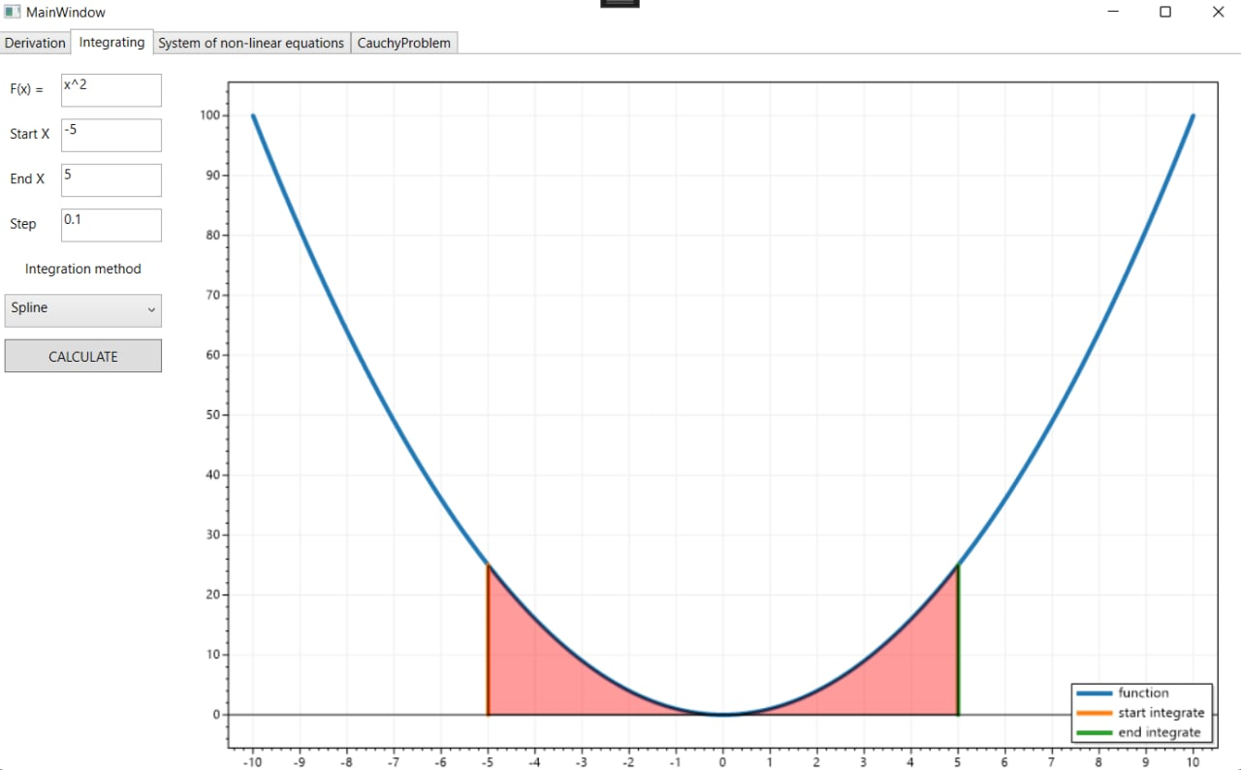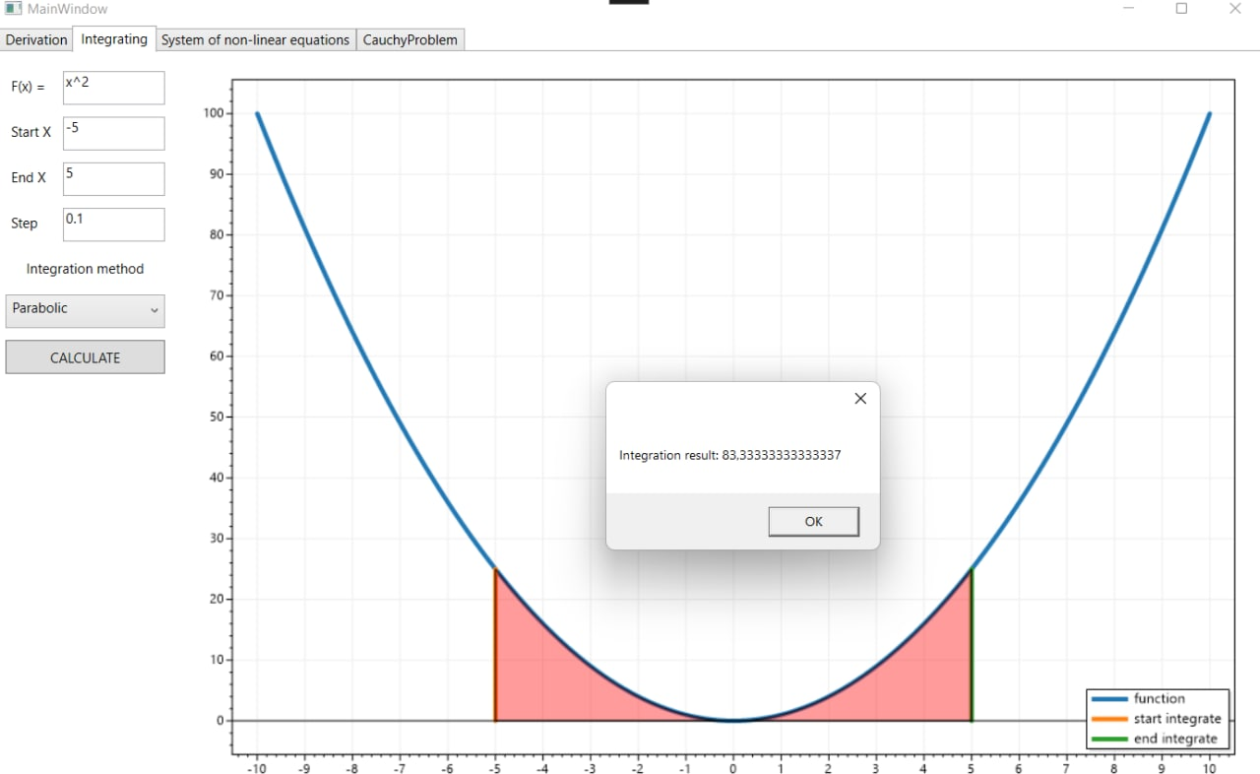

**Структура проекта**

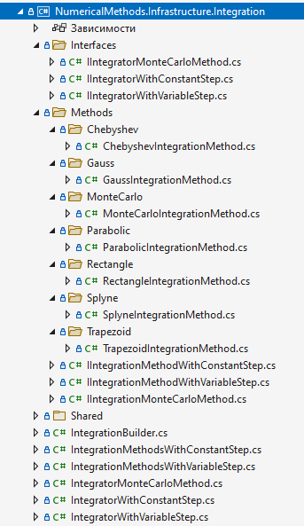

**Листинг работы программы**

Листинг класса ChebyshevIntegrationMethod

using MathNet.Symbolics;

using NumericalMethods.Infrastructure.Integration.Shared;

using NumericalMethods.Infrastructure.NonLinearEquationsSystems;

using NumericalMethods.Infrastructure.NonLinearEquationsSystems.Interfaces;

namespace NumericalMethods.Infrastructure.Integration.Methods.Chebyshev;

public class ChebyshevIntegrationMethod : IIntegrationMethodWithVariableStep

{

/// <summary> Интегрирование отрезка функции </summary>

/// <param name="function"> Подинтегральная функция </param>

/// <param name="start"> Начало отрезка интегрирования </param>

/// <param name="end"> Конец отрезка интегрирования </param>

/// <param name="count_nodes"> Количество разбиений отрезка интегрирования </param>

/// <returns></returns>

public double Integrate(string function, double start, double end, int count_nodes)

{

SymbolicExpression functionExpression = SymbolicExpression.Parse(function);

IEnumerable<double> tRoots = GetRootsForCountNodes(count_nodes);

IEnumerable<double> xCoefs = tRoots.Select(tRoot => GetRealX(start, end, tRoot));

IEnumerable<double> aCoefs = Enumerable.Repeat(2.0 / count_nodes, count_nodes);

IEnumerable<double> aCoefsMultiplyedYs = aCoefs.Zip(aCoefs, (aCoef, xCoef) => aCoef * functionExpression.EvaluateX(xCoef));

return (end - start) / 2 * aCoefsMultiplyedYs.Sum();

}

/// <summary> Функция зависимости x от t </summary>

/// <param name="a"> Начало отрезка интегрирования </param>

/// <param name="b"> Конеч отрезка интегрирования </param>

/// <param name="t"> Значение коэффициента t </param>

private static double GetRealX(double a, double b, double t)

{

return (a + b) / 2 + (b - a) / 2 * t;

}

/// <summary> Возвращает значения корней Чебышева для определенного количества разбиений отрезка интегрирования </summary>

/// <param name="countNodes"> Количество разбиений </param>

/// <exception cref="NotImplementedException"></exception>

private static IEnumerable<double> GetRootsForCountNodes(int countNodes)

{

return countNodes switch

{

3 => new double[3] { 0.707107, 0, -0.707107 },

4 => new double[4] { 0.794654, 0.187592, -0.794654, -0.187592 },

5 => new double[5] { 0.832498, 0.374541, 0, -0.832498, -0.374541 },

6 => new double[6] { 0.866247, 0.422519, 0.266635, -0.866247, -0.422519, -0.266635 },

7 => new double[7] { 0.883862, 0.529657, 0.323912, 0, -0.883862, -0.529657, -0.323912 },

9 => new double[9] { 0.911589, 0.601019, 0.528762, 0.167906, 0, -0.911589, -0.601019, -0.528762, -0.167906 },

_ => throw new NotImplementedException($"Для размерности {countNodes} метод не реализован")

};

}

/// <summary> Создает задачу поиска начального приближения для вычисления значений корней Чебышева </summary>

private Task<IEnumerable<double>?> CreateRootFinder(List<string> expressions, CancellationToken token)

{

return Task.Run(() =>

{

List<string> expressionsCopy = expressions.ToList();

NonLinearEquationsSystem snu = new NonLinearEquationsSystem(expressionsCopy);

INonLinearEquationsSystemsSolver solver = new NonLinearEquationsSolverBuilder().Build(SolvingMethods.Newton);

bool success = false;

Random random = new Random();

IEnumerable<double> randomInitial = new double[snu.FunctionExpressions.Count()].Select(value => random.Next(-1, 2) + random.NextDouble());

IEnumerable<double> findedRoots = null;

while (success is false)

{

try

{

if (token.IsCancellationRequested) break;

//findedRoots = solver.Solve(snu, 0.001d, randomInitial);

if (findedRoots.Any(root => double.IsNaN(root) || root is < -1 or > 1))

{

randomInitial = randomInitial.Select(value => random.Next(-1, 2) + random.NextDouble());

continue;

}

success = true;

} catch { randomInitial = randomInitial.Select(value => random.Next(-1, 2) + random.NextDouble()); }

}

return findedRoots;

}, token);

}

Листинг класса GaussIntegrationMethod

using MathNet.Symbolics;

using NumericalMethods.Infrastructure.Integration.Shared;

namespace NumericalMethods.Infrastructure.Integration.Methods.Gauss

{

internal class GaussIntegrationMethod : IIntegrationMethodWithVariableStep

{

public double Integrate(string function, double start, double end, int count_nodes)

{

SymbolicExpression func = SymbolicExpression.Parse(function);

double[] acoef = new double[count_nodes];

double[] x = new double[count_nodes];

for (int i = 1; i <= count_nodes; i++)

{

double ti = T(count_nodes - 1, i, count_nodes);

double pd = PD(count_nodes, ti);

double diva = (1 - ti * ti) * pd * pd;

acoef[i - 1] = 2 / diva;

x[i - 1] = GetRealX(start, end, ti);

}

return (end - start) / 2 * acoef.Zip(x, (ac, xc) => ac * func.EvaluateX(xc)).Sum();

}

double GetRealX(double a, double b, double t)

{

return (a + b) / 2 + (b - a) / 2 * t;

}

double T(int k, int i, int n)

{

if (k == 0)

{

double t1 = Math.PI * (4 * i - 1);

double t2 = 4 * n + 2;

return Math.Cos(t1 / t2);

}

double tprev = T(k - 1, i, n);

return tprev - P(n, tprev) / PD(n, tprev);

}

double P(double n, double t)

{

return n switch

{

0 => 1,

1 => t,

_ => (2 * (n - 1) + 1) / ((n - 1) + 1) * t * P(n - 1, t)

- (n - 1) / ((n - 1) + 1) * P(n - 2, t)

};

}

double PD(double n, double t)

{

double left = n / (1 - t * t);

double right = P(n - 1, t) - t * P(n, t);

return left * right;

}

}

}

Листинг класса MonteCarloIntegrationMethod

using MathNet.Symbolics;

using NumericalMethods.Infrastructure.Integration.Shared;

namespace NumericalMethods.Infrastructure.Integration.Methods.MonteCarlo

{

internal class MonteCarloIntegrationMethod : IIntegrationMonteCarloMethod

{

public double Integrate(string function, double start, double end, int count_points)

{

SymbolicExpression func = SymbolicExpression.Parse(function);

Random rnd = new Random();

double x = start, sumValuesFunctions = 0;

for (int i = 0; i < count_points; i++)

{

while(x <= start || x > end)

x = rnd.Next((int)start, (int)end) + rnd.NextDouble();

sumValuesFunctions += func.EvaluateX(x);

x = start;

}

return (end - start) / count_points * sumValuesFunctions;

}

}

}

Листинг класса ParabolicIntegrationMethod

using MathNet.Symbolics;

using NumericalMethods.Infrastructure.Integration.Shared;

namespace NumericalMethods.Infrastructure.Integration.Methods.Parabolic;

public class ParabolicIntegrationMethod : IIntegrationMethodWithConstantStep

{

public double Integrate(string function, double start, double end, double step)

{

SymbolicExpression func = SymbolicExpression.Parse(function);

double valueEvenFunction = 0, valueOddFunction = 0;

int i = 0;

for (double x = start + step; x < end - step; x += step)

if (++i % 2 == 0)

valueEvenFunction += func.EvaluateX(x);

else

valueOddFunction += func.EvaluateX(x);

return step / 3 * (func.EvaluateX(start) + (4 * valueOddFunction) + (2 * valueEvenFunction) + func.EvaluateX(end));

}

}

Листинг класса RectangleIntegrationMethod

using MathNet.Symbolics;

using NumericalMethods.Infrastructure.Integration.Shared;

namespace NumericalMethods.Infrastructure.Integration.Methods.Rectangle;

internal class RectangleIntegrationMethod : IIntegrationMethodWithConstantStep

{

public double Integrate(string function, double start, double end, double step)

{

SymbolicExpression func = SymbolicExpression.Parse(function);

double resulted_sum = 0;

for (double xi = start + (step / 2); xi < end; xi += step)

resulted_sum += step * func.EvaluateX(xi);

return resulted_sum;

}

}

Листинг класса SplyneIntegrationMethod

using NumericalMethods.Infrastructure.Integration.Methods.Trapezoid;

using MathNet.Symbolics;

using NumericalMethods.Infrastructure.Integration.Shared;

namespace NumericalMethods.Infrastructure.Integration.Methods.Splyne

{

public record class SplyneIntegrationMethod : IIntegrationMethodWithConstantStep

{

public double Integrate(string function, double start, double end, double step)

{

SymbolicExpression func = SymbolicExpression.Parse(function);

double inaccuracyTrapezoidMethod = 0;//Погрешность метода трапеции

double trapezoidIntegral = new TrapezoidIntegrationMethod().Integrate(function, start, end, step); // Первая часть функции Сплайна

for (double x = start + step; x < end; x += step)

inaccuracyTrapezoidMethod += Math.Pow(step, 3) * func.Derivative(x, 2);

return trapezoidIntegral - (inaccuracyTrapezoidMethod / 12);

}

}

}

Листинг класса TrapezoidIntegrationMethod

using MathNet.Symbolics;

using NumericalMethods.Infrastructure.Integration.Shared;

namespace NumericalMethods.Infrastructure.Integration.Methods.Trapezoid;

public class TrapezoidIntegrationMethod : IIntegrationMethodWithConstantStep

{

public double Integrate(string function, double start, double end, double step)

{

SymbolicExpression func = SymbolicExpression.Parse(function);

double sumElement = 0;

for (double x = start + step; x < end; x += step)

sumElement += step * (func.EvaluateX(x - step) + func.EvaluateX(x));

return sumElement / 2;

}

}

Листинг класса IntegrationBuilder

using NumericalMethods.Infrastructure.Integration.Interfaces;

using NumericalMethods.Infrastructure.Integration.Methods.Parabolic;

using NumericalMethods.Infrastructure.Integration.Methods.Rectangle;

using NumericalMethods.Infrastructure.Integration.Methods.Splyne;

using NumericalMethods.Infrastructure.Integration.Methods.Trapezoid;

using NumericalMethods.Infrastructure.Integration.Methods.MonteCarlo;

using NumericalMethods.Infrastructure.Integration.Methods.Gauss;

using NumericalMethods.Infrastructure.Integration.Methods.Chebyshev;

namespace NumericalMethods.Infrastructure.Integration;

public record class IntegrationBuilder

{

public IIntegratorWithConstantStep Build(string function, IntegrationMethodsWithConstantStep method)

{

return method switch

{

IntegrationMethodsWithConstantStep.Rectangle => new IntegratorWithConstantStep(new RectangleIntegrationMethod(), function),

IntegrationMethodsWithConstantStep.Trapeze => new IntegratorWithConstantStep(new TrapezoidIntegrationMethod(), function),

IntegrationMethodsWithConstantStep.Parabolic => new IntegratorWithConstantStep(new ParabolicIntegrationMethod(), function),

IntegrationMethodsWithConstantStep.Spline => new IntegratorWithConstantStep(new SplyneIntegrationMethod(), function),

_ => new IntegratorWithConstantStep(new SplyneIntegrationMethod(), function)

};

}

public IIntegratorWithVariableStep Build(string function, IntegrationMethodsWithVariableStep method)

{

return method switch

{

IntegrationMethodsWithVariableStep.Gauss => new IntegratorWithVariableStep(new GaussIntegrationMethod(),function),

IntegrationMethodsWithVariableStep.Chebyshev => new IntegratorWithVariableStep(new ChebyshevIntegrationMethod(), function),

_ => throw new NotImplementedException()

};

}

public IIntegratorMonteCarloMethod BuildMonteCarlo(string function)

{

return new IntegratorMonteCarloMethod(new MonteCarloIntegrationMethod(), function);

}

}

Листинг класса IntegratorMonteCarloMethod

using NumericalMethods.Infrastructure.Integration.Interfaces;

using NumericalMethods.Infrastructure.Integration.Methods;

namespace NumericalMethods.Infrastructure.Integration

{

internal record class IntegratorMonteCarloMethod(IIntegrationMonteCarloMethod IntegrationMethod, string Function) : IIntegratorMonteCarloMethod

{

public double Integrate(double start, double end, int count_points)

{

return IntegrationMethod.Integrate(Function, start, end, count_points);

}

}

}

Листинг класса IntegrationMethodsWithConstantStep

namespace NumericalMethods.Infrastructure.Integration;

public enum IntegrationMethodsWithConstantStep

{

Rectangle = 0,

Trapeze = 1,

Parabolic = 2,

Spline = 3

}

Листинг класса IntegrationMethodsWithVariableStep

namespace NumericalMethods.Infrastructure.Integration;

public enum IntegrationMethodsWithVariableStep

{

Gauss = 0,

Chebyshev = 1

}

Листинг класса IntegratorMonteCarloMethod

using NumericalMethods.Infrastructure.Integration.Interfaces;

using NumericalMethods.Infrastructure.Integration.Methods;

namespace NumericalMethods.Infrastructure.Integration

{

internal record class IntegratorMonteCarloMethod(IIntegrationMonteCarloMethod IntegrationMethod, string Function) : IIntegratorMonteCarloMethod

{

public double Integrate(double start, double end, int count_points)

{

return IntegrationMethod.Integrate(Function, start, end, count_points);

}

}

}

Листинг класса IntegratorWithConstantStep

using NumericalMethods.Infrastructure.Integration.Interfaces;

using NumericalMethods.Infrastructure.Integration.Methods;

namespace NumericalMethods.Infrastructure.Integration;

internal record class IntegratorWithConstantStep(IIntegrationMethodWithConstantStep IntegrationMethod, string Function) : IIntegratorWithConstantStep

{

public double Integrate(double start, double end, double step)

{

return IntegrationMethod.Integrate(Function, start, end, step);

}

}

Листинг класса IntegratorWithVariableStep

using NumericalMethods.Infrastructure.Integration.Interfaces;

using NumericalMethods.Infrastructure.Integration.Methods;

namespace NumericalMethods.Infrastructure.Integration;

internal record class IntegratorWithVariableStep(IIntegrationMethodWithVariableStep IntegrationMethod, string Function) : IIntegratorWithVariableStep

{

public double Integrate(double start, double end, int count_nodes)

{

return IntegrationMethod.Integrate(Function, start, end, count_nodes);

}

}

Листинг класса IIntegratorMonteCarloMethod

namespace NumericalMethods.Infrastructure.Integration.Interfaces

{

public interface IIntegratorMonteCarloMethod

{

public double Integrate(double start, double end, int count_points);

}

}

Листинг класса IIntegratorWithConstantStep

namespace NumericalMethods.Infrastructure.Integration.Interfaces;

public interface IIntegratorWithConstantStep

{

public double Integrate(double start, double end, double step);

}

Листинг класса IIntegratorWithVariableStep

namespace NumericalMethods.Infrastructure.Integration.Interfaces;

public interface IIntegratorWithVariableStep

{

public double Integrate(double start, double end, int count_nodes);

}

Листинг класса IIntegrationMethodWithConstantStep

using NumericalMethods.Infrastructure.Integration.Interfaces;

namespace NumericalMethods.Infrastructure.Integration.Methods;

internal interface IIntegrationMethodWithConstantStep

{

public double Integrate(string function, double start, double end, double step);

}

Листинг класса IIntegrationMethodWithVariableStep

using NumericalMethods.Infrastructure.Integration.Interfaces;

namespace NumericalMethods.Infrastructure.Integration.Methods;

internal interface IIntegrationMethodWithVariableStep

{

public double Integrate(string function, double start, double end, int count_nodes);

}

Листинг класса IIntegrationMonteCarloMethod

namespace NumericalMethods.Infrastructure.Integration.Methods

{

internal interface IIntegrationMonteCarloMethod

{

public double Integrate(string function, double start, double end, int count_points);

}

}

Листинг класса MainWindow.xaml

namespace NumericalMethods.WPFApplication

{

/// <summary>

/// Interaction logic for MainWindow.xaml

/// </summary>

public partial class MainWindow : Window

{

private readonly List<Point> _points = new List<Point>();

private Function _current_function;

private double _start_x;

private double _end_x;

private double _step;

private int _order;

private ResultTable _resultTable;

public MainWindow()

{

InitializeComponent();

Width = 1300;

Height = 750;

InitializeIntegration();

}

private void InitializeIntegration()

{

foreach (var item in Enum.GetValues(typeof(IntegrationMethodsWithConstantStep)))

{

Integration_MethodComboBox.Items.Add(item.ToString());

}

foreach(var item in Enum.GetValues(typeof(IntegrationMethodsWithVariableStep)))

{

Integration_MethodComboBox.Items.Add(item.ToString());

}

Integration_MethodComboBox.Items.Add("MonteCarlo");

Integration_MethodComboBox.SelectedItem = Integration_MethodComboBox.Items[0];

Integration_FunctionTextBox.Text = "x^2";

Integration_StartXTextBox.Text = "-5";

Integration_EndXTextBox.Text = "5";

Integration_StepTextBox.Text = "0.1";

Integration_MainChart.Plot.Legend(enable: true);

}

private void Integration_MethodComboBox_SelectionChanged(object sender, SelectionChangedEventArgs e)

{

if (Enum.IsDefined(typeof(IntegrationMethodsWithConstantStep), ((ComboBox)sender).SelectedValue))

{

Integration_CountNodesGrid.Visibility = Visibility.Collapsed;

Integration_CountPointGrid.Visibility = Visibility.Collapsed;

}

if (Enum.IsDefined(typeof(IntegrationMethodsWithVariableStep), ((ComboBox)sender).SelectedValue))

{

Integration_CountNodesGrid.Visibility = Visibility.Visible;

Integration_CountPointGrid.Visibility = Visibility.Collapsed;

}

if (((ComboBox)sender).SelectedValue.ToString() == "MonteCarlo")

{

Integration_CountNodesGrid.Visibility = Visibility.Collapsed;

Integration_CountPointGrid.Visibility = Visibility.Visible;

}

Integration_CountPointTextBox.Text = "";

Integration_CountNodesTextBox.Text = "";

}

private void Integration_CalculateButton_Click(object sender, RoutedEventArgs e)

{

Integration_MainChart.Plot.Clear();

if (String.IsNullOrEmpty(Integration_FunctionTextBox.Text)||

String.IsNullOrEmpty(Integration_StartXTextBox.Text)||

String.IsNullOrEmpty(Integration_EndXTextBox.Text)||

String.IsNullOrEmpty(Integration_StepTextBox.Text))

{

MessageBox.Show("Для начала рассчёта, заполните все поля");

return;

}

Function function = new Function("f(x) = " + Integration_FunctionTextBox.Text.Trim());

double start_x = new Expression(Integration_StartXTextBox.Text.Trim()).calculate();

double end_x = new Expression(Integration_EndXTextBox.Text.Trim()).calculate();

double step = new Expression(Integration_StepTextBox.Text.Trim()).calculate();

string function_type_string = Integration_MethodComboBox.SelectedValue.ToString();

double integration_result = 0;

if (Enum.IsDefined(typeof(IntegrationMethodsWithConstantStep), function_type_string))

{

IntegrationMethodsWithConstantStep method = (IntegrationMethodsWithConstantStep)Enum.Parse(typeof(IntegrationMethodsWithConstantStep), function_type_string);

IIntegratorWithConstantStep integrator = new IntegrationBuilder().Build(Integration_FunctionTextBox.Text.Trim(), method);

integration_result = integrator.Integrate(start_x, end_x, step);

}

if (Enum.IsDefined(typeof(IntegrationMethodsWithVariableStep), function_type_string))

{

if (String.IsNullOrEmpty(Integration_CountNodesTextBox.Text))

{

MessageBox.Show("Для начала рассчёта, заполните поле count nodes");

return;

}

int countNodes = int.Parse(Integration_CountNodesTextBox.Text);

IntegrationMethodsWithVariableStep method = (IntegrationMethodsWithVariableStep)Enum.Parse(typeof(IntegrationMethodsWithVariableStep), function_type_string);

IIntegratorWithVariableStep integrator = new IntegrationBuilder().Build(Integration_FunctionTextBox.Text.Trim(), method);

integration_result = integrator.Integrate(start_x, end_x, countNodes);

}

if (function_type_string == "MonteCarlo")

{

if (String.IsNullOrEmpty(Integration_CountPointTextBox.Text))

{

MessageBox.Show("Для начала рассчёта, заполните поле count point");

return;

}

int countPoints = int.Parse(Integration_CountPointTextBox.Text);

IIntegratorMonteCarloMethod integrator = new IntegrationBuilder().BuildMonteCarlo(Integration_FunctionTextBox.Text.Trim());

integration_result = integrator.Integrate(start_x, end_x, countPoints);

}

(double[] xs, double[] ys) = DataGenerate(function, start_x - 5, end_x + 5, step);

Integration_MainChart.Plot.AddScatter(xs.ToArray(), ys.ToArray(), lineWidth: 4, markerSize: 0, label: "function");

double[] interval_start_x = { start_x, start_x };

double[] interval_start_y = { 0, function.calculate(start_x) };

Integration_MainChart.Plot.AddScatter(interval_start_x, interval_start_y, lineWidth: 4, markerSize: 0, label: "start integrate");

double[] interval_end_x = { end_x, end_x };

double[] interval_end_y = { 0, function.calculate(end_x) };

Integration_MainChart.Plot.AddScatter(interval_end_x, interval_end_y, lineWidth: 4, markerSize: 0, label: "end integrate");

(double[] fill_xs, double[] fill_ys) = DataGenerate(function, start_x, end_x, step);

Integration_MainChart.Plot.AddFill(fill_xs, fill_ys, baseline: 0, color: System.Drawing.Color.FromArgb(100, System.Drawing.Color.Red));

Integration_MainChart.Plot.AddHorizontalLine(0, color: System.Drawing.Color.Black);

Integration_MainChart.Refresh();

MessageBox.Show($"Integration result: {integration_result}");

}

}

}

**Вывод**: в ходе выполнения лабораторной работы были получены практические навыки численного интегрирования с использованием основных методом: метод прямоугольников, методя трапеций, метод парабол (метод Симпсона), метода сплайнов, метод Монте-Карло, метод Гаусса, метода Чебышева.

## Лабораторная работа №4

### «Методы решения дифференциальных уравнений»

**Цель работы**: изучение методов решения дифференциальных уравнений в частных производных и приобретение навыков решения практических задач с использованием программного средства Matlab.

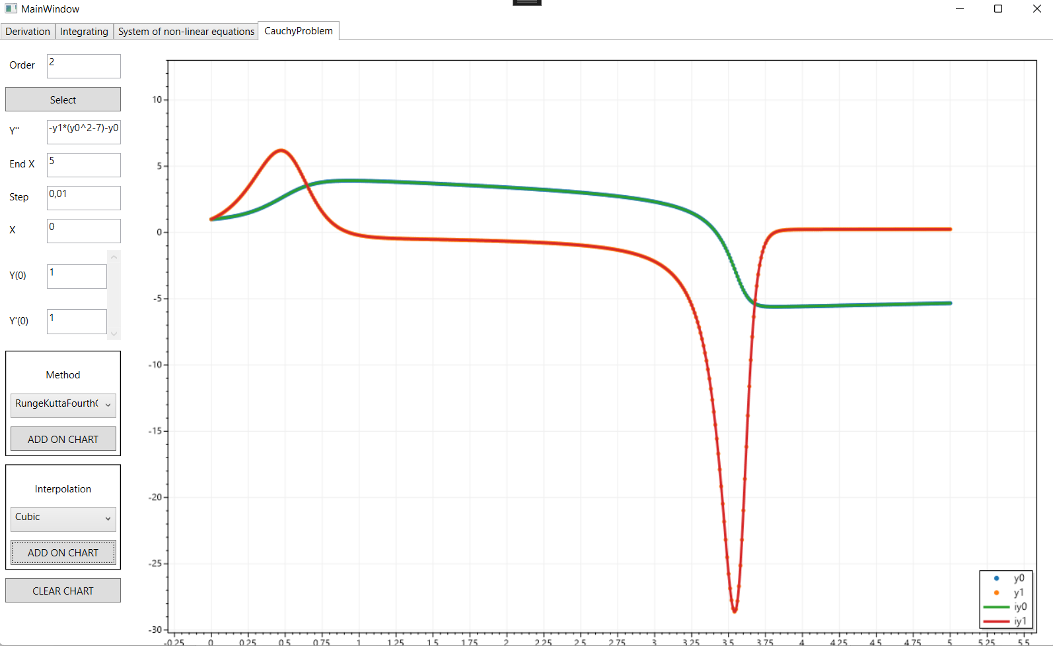**Скриншоты работы программы**

tk = [0:0.01:5];

x0 = [1 1];

[T X] = ode45('diffsys',tk,x0);

plot(T,X)

grid on

xlabel('x')

ylabel('y')

function dxdt = diffsys(t,x)

dxdt(1,1) = x(2);

dxdt(2,1) = -x(2)*(x(1).^2-7)-x(1);

end

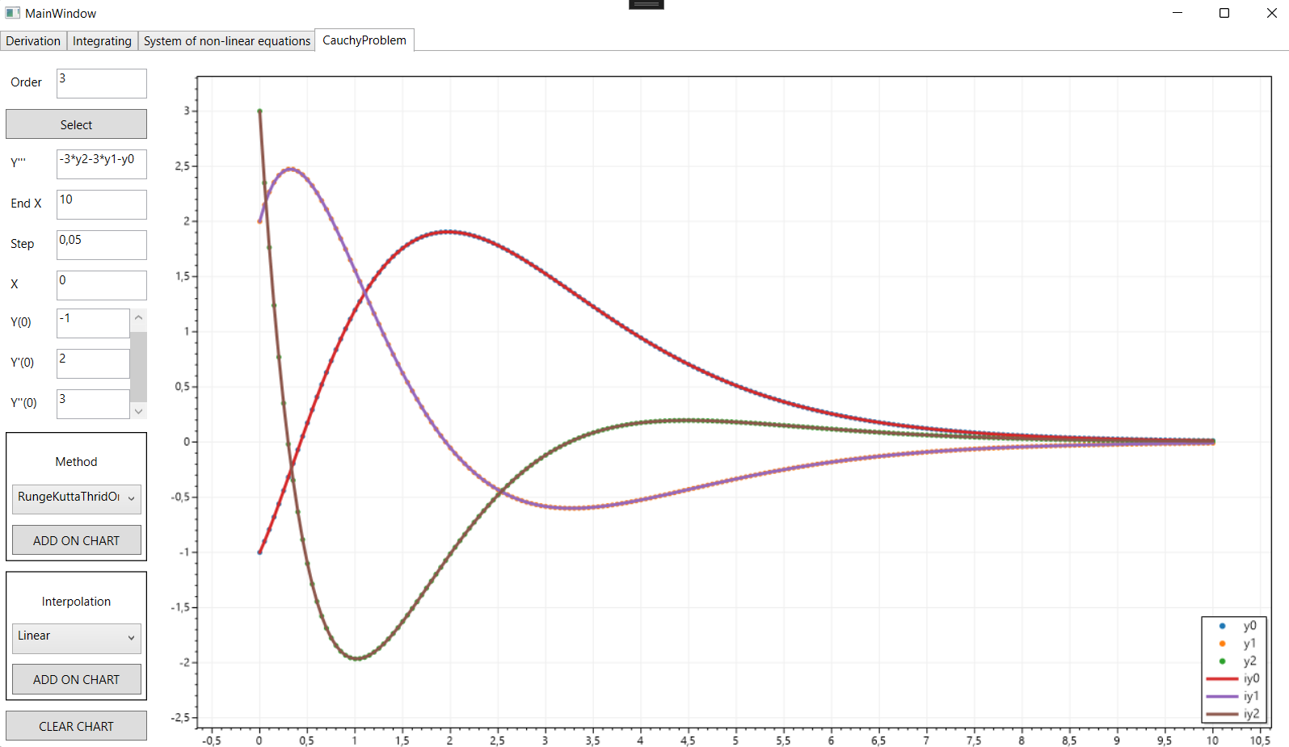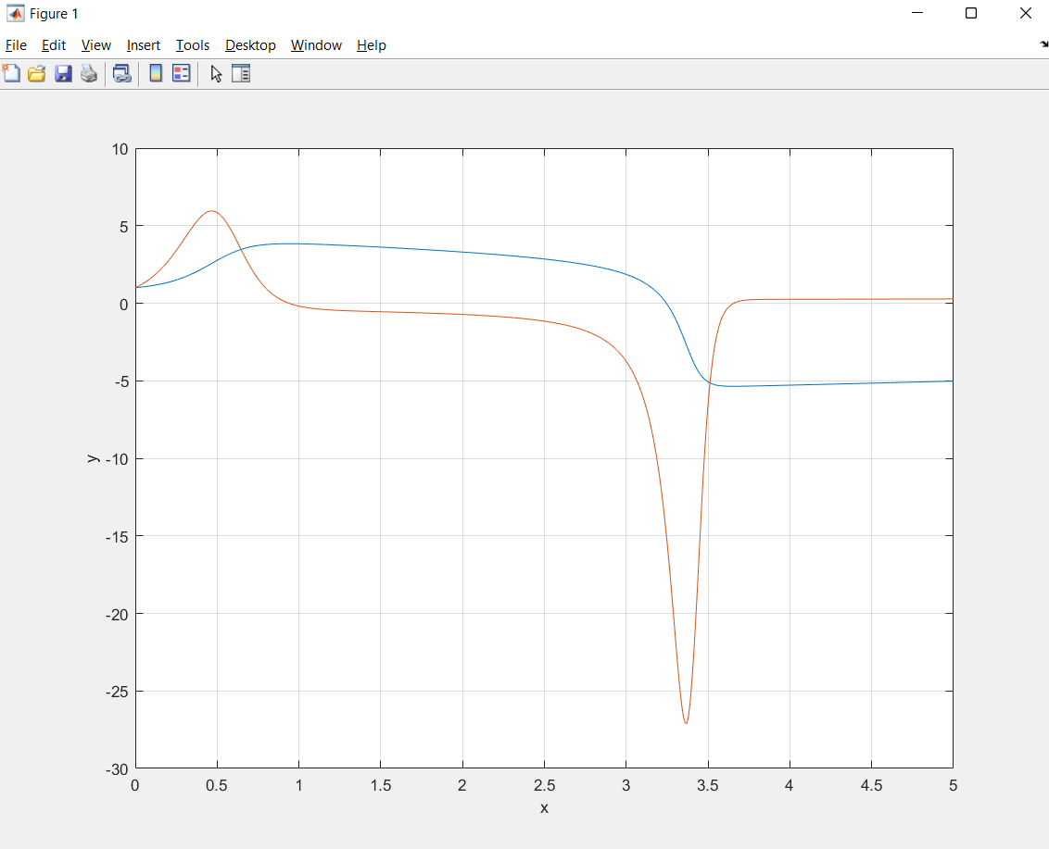tk = [0:0.01:10];

x0 = [-1 2 3];

[T X] = ode45('diffsys',tk,x0);

plot(T,X)

grid on

xlabel('x')

ylabel('y')

function dxdt = diffsys(t,x)

dxdt(1,1) = x(2);

dxdt(2,1) = x(3);

dxdt(3,1) = -3*x(3)-3*x(2)-x(1);

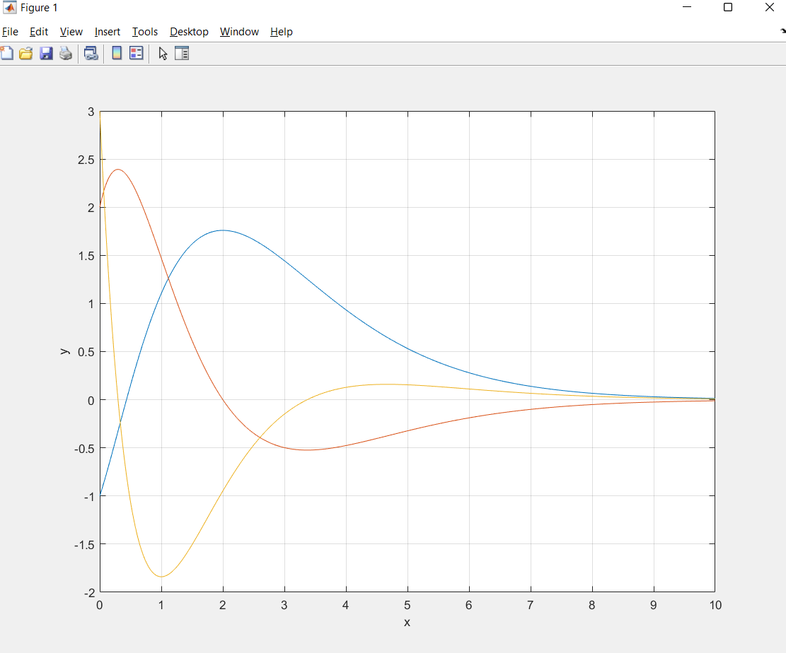end

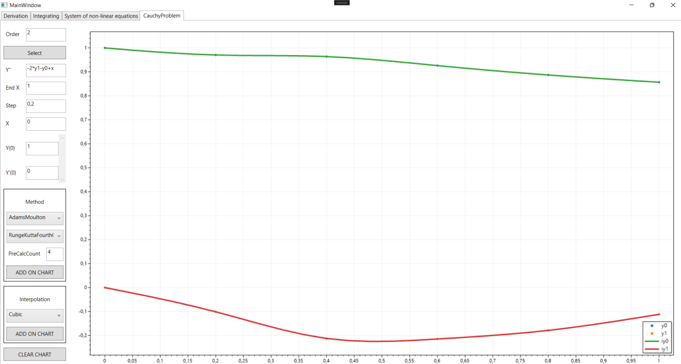

clear, clc

tk = [0:0.2:1];

x0 = [1 0];

[T X] = ode45('diffsys',tk,x0);

plot(T,X)

grid on

xlabel('x')

ylabel('y')

function dxdt = diffsys(t, x)

dxdt(1,1) = x(2);

dxdt(2,1) = -2*x(2)-x(1) + t;

end

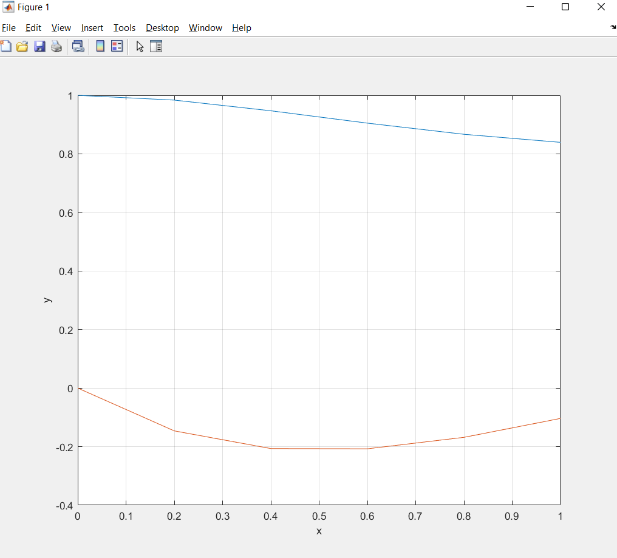

**Структура проекта**

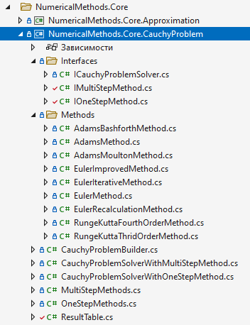

**Листинг работы программы**

Листинг класса EulerMethod

using MathNet.Symbolics;

using NumericalMethods.Core.CauchyProblem.Interfaces;

namespace NumericalMethods.Core.CauchyProblem.Methods;

internal class EulerMethod : IOneStepMethod

{

public double Calculate(SymbolicExpression function, double h, double x, (string name, double value) yi, Dictionary<string, FloatingPoint> conditions)

{

return yi.value + h * function.Evaluate(conditions).RealValue;

}

}

Листинг класса EulerRecalculationMethod

using MathNet.Symbolics;

using NumericalMethods.Core.CauchyProblem.Interfaces;

namespace NumericalMethods.Core.CauchyProblem.Methods;

internal class EulerRecalculationMethod : IOneStepMethod

{

public double Calculate(SymbolicExpression function, double h, double x, (string name, double value) yi, Dictionary<string, FloatingPoint> conditions)

{

Dictionary<string, FloatingPoint> conditionsCopy = conditions.ToDictionary(pair => pair.Key, pair => pair.Value);

double functionValue = function.Evaluate(conditionsCopy).RealValue;

double y_next_approximation = yi.value + h * functionValue;

conditionsCopy["x"] = x + h;

conditionsCopy[yi.name] = y_next_approximation;

return yi.value + (h * (functionValue + function.Evaluate(conditionsCopy).RealValue)) / 2;

}

}

Листинг класса EulerIterativeMethod

using MathNet.Symbolics;

using NumericalMethods.Core.CauchyProblem.Interfaces;

namespace NumericalMethods.Core.CauchyProblem.Methods;

internal class EulerIterativeMethod : IOneStepMethod

{

public double Calculate(SymbolicExpression function, double h, double x, (string name, double value) yi, Dictionary<string, FloatingPoint> conditions)

{

Dictionary<string, FloatingPoint> conditionsCopy = conditions.ToDictionary(pair => pair.Key, pair => pair.Value);

double functionValue = function.Evaluate(conditionsCopy).RealValue;

double y_next = yi.value + h * functionValue;

conditionsCopy["x"] = x + h;

for (int k = 0; k < 4; k++)

{

conditionsCopy[yi.name] = y_next;

y_next = yi.value + h * (functionValue + function.Evaluate(conditionsCopy).RealValue) / 2;

}

return y_next;

}

}

Листинг класса EulerImprovedMethod

using MathNet.Symbolics;

using NumericalMethods.Core.CauchyProblem.Interfaces;

namespace NumericalMethods.Core.CauchyProblem.Methods;

public class EulerImprovedMethod : IOneStepMethod

{

public double Calculate(SymbolicExpression function, double h, double x, (string name, double value) yi, Dictionary<string, FloatingPoint> conditions)

{

Dictionary<string, FloatingPoint> conditionsCopy = conditions.ToDictionary(pair => pair.Key, pair => pair.Value);

double y_half = yi.value + h / 2 * function.Evaluate(conditionsCopy).RealValue;

conditionsCopy["x"] = x + h / 2;

conditionsCopy[yi.name] = y_half;

return yi.value + h * function.Evaluate(conditionsCopy).RealValue;

}

}

Листинг класса RungeKuttaThridOrderMethod

using MathNet.Symbolics;

using NumericalMethods.Core.CauchyProblem.Interfaces;

namespace NumericalMethods.Core.CauchyProblem.Methods;

public class RungeKuttaThridOrderMethod : IOneStepMethod

{

public double Calculate(SymbolicExpression function, double h, double x, (string name, double value) yi, Dictionary<string, FloatingPoint> conditions)

{

Dictionary<string, FloatingPoint> conditionsCopy = conditions.ToDictionary(pair => pair.Key, pair => pair.Value);

double y_delta, k_one, k_two, k_three;

k_one = h * function.Evaluate(conditionsCopy).RealValue;

conditionsCopy["x"] = x + h / 3;

conditionsCopy[yi.name] = yi.value + k_one / 3;

k_two = h * function.Evaluate(conditionsCopy).RealValue;

conditionsCopy["x"] = x + h * 2.0 / 3.0;

conditionsCopy[yi.name] = yi.value + k_two * 2.0 / 3.0;

k_three = h * function.Evaluate(conditionsCopy).RealValue;

y_delta = (k_one + 3 * k_three) / 4;

return yi.value + y_delta;

}

}

Листинг класса RungeKuttaFourthOrderMethod

using MathNet.Symbolics;

using NumericalMethods.Core.CauchyProblem.Interfaces;

namespace NumericalMethods.Core.CauchyProblem.Methods;

public class RungeKuttaFourthOrderMethod : IOneStepMethod

{

public double Calculate(SymbolicExpression function, double h, double x, (string name, double value) yi, Dictionary<string, FloatingPoint> conditions)

{

Dictionary<string, FloatingPoint> conditionsCopy = conditions.ToDictionary(pair => pair.Key, pair => pair.Value);

double y_delta, k_one, k_two, k_three, k_four;

k_one = h * function.Evaluate(conditionsCopy).RealValue;

conditionsCopy["x"] = x + h / 2;

conditionsCopy[yi.name] = yi.value + k_one / 2;

k_two = h * function.Evaluate(conditionsCopy).RealValue;

conditionsCopy[yi.name] = yi.value + k_two / 2;

k_three = h * function.Evaluate(conditionsCopy).RealValue;

conditionsCopy["x"] = x + h;

conditionsCopy[yi.name] = yi.value + k_three;

k_four = h * function.Evaluate(conditionsCopy).RealValue;

y_delta = (k_one + 2 * k_two + 2 * k_three + k_four) / 6;

return yi.value + y_delta;

}

}

Листинг класса AdamsMethod

using MathNet.Symbolics;

using NumericalMethods.Core.CauchyProblem.Interfaces;

namespace NumericalMethods.Core.CauchyProblem.Methods;

public class AdamsMethod : IMultiStepMethod

{

public ResultTable Calculate(List<SymbolicExpression> functions, double b, double h, ResultTable initialResult)

{

if (initialResult.CountRow < 4) throw new ArgumentException($"{nameof(initialResult)} count row less then 4");

for (double current_x = initialResult["x"].Last().x + h; current_x <= b; current_x += h)

{

Dictionary<string, double> new_ys = new Dictionary<string, double>();

List<Dictionary<string, FloatingPoint>> last_four_rows = initialResult.GetRows(^4..)

.Select(row => row.Select(pair => new KeyValuePair<string, FloatingPoint>(pair.Key, pair.Value))

.ToDictionary(pair => pair.Key, pair => pair.Value))

.ToList();

for (int i = 0; i < functions.Count; i++)

{

string current_y_name = last_four_rows.Last().ElementAt(i + 1).Key;

double current_y_value = last_four_rows.Last()[current_y_name].RealValue;

double fi = functions[i].Evaluate(last_four_rows.Last()).RealValue;

double fi_minus_one = functions[i].Evaluate(last_four_rows.SkipLast(1).Last()).RealValue;

double fi_minus_two = functions[i].Evaluate(last_four_rows.SkipLast(2).Last()).RealValue;

double fi_minus_three = functions[i].Evaluate(last_four_rows.SkipLast(3).Last()).RealValue;

double delta_f = fi - fi_minus_one;

double delta_f_two = fi - 2 * fi_minus_one + fi_minus_two;

double delta_f_three = fi - 3 * fi_minus_one + 3 * fi_minus_two - fi_minus_three;

double new_y_value = current_y_value + fi * h + Math.Pow(h, 2) / 2.0 * delta_f + 5 * Math.Pow(h, 3) / 12.0 * delta_f_two + 3 * Math.Pow(h, 4) / 8.0 * delta_f_three;

new_ys.Add(current_y_name, new_y_value);

}

initialResult.Add(current_x, new_ys);

}

return initialResult;

}

}

Листинг класса AdamsBashforthMethod

using MathNet.Symbolics;

using NumericalMethods.Core.CauchyProblem.Interfaces;

namespace NumericalMethods.Core.CauchyProblem.Methods;

public class AdamsBashforthMethod : IMultiStepMethod

{

public ResultTable Calculate(List<SymbolicExpression> functions, double b, double h, ResultTable initialResult)

{

if (initialResult.CountRow < 1) throw new ArgumentException($"{nameof(initialResult)} count row less then 1");

Func<Dictionary<string, double>, Dictionary<string, FloatingPoint>> convert_with_floating_point =

(row) => row

.Select(pair => new KeyValuePair<string, FloatingPoint>(pair.Key, pair.Value))

.ToDictionary(pair => pair.Key, pair => pair.Value);

double current_x = initialResult["x"].Last().x + h;

if (initialResult.CountRow == 1)

{

Dictionary<string, double> new_ys = new Dictionary<string, double>();

Dictionary<string, FloatingPoint> first_row = convert_with_floating_point(initialResult.GetRow(0));

for (int i = 0; i < functions.Count; i++)

{

string current_y_name = first_row.ElementAt(i + 1).Key;

double current_y_value = first_row[current_y_name].RealValue;

double new_y_value = current_y_value + h * functions[i].Evaluate(first_row).RealValue;

new_ys.Add(current_y_name, new_y_value);

}

initialResult.Add(current_x, new_ys);

current_x += h;

if (current_x > b) return initialResult;

}

if (initialResult.CountRow == 2)

{

Dictionary<string, double> new_ys = new Dictionary<string, double>();

Dictionary<string, FloatingPoint> first_row = convert_with_floating_point(initialResult.GetRow(0));

Dictionary<string, FloatingPoint> second_row = convert_with_floating_point(initialResult.GetRow(1));

for (int i = 0; i < functions.Count; i++)

{

string current_y_name = second_row.ElementAt(i + 1).Key;

double current_y_value = second_row[current_y_name].RealValue;

double new_y_value = current_y_value + h * (3.0 / 2.0 * functions[i].Evaluate(second_row).RealValue

- 1.0 / 2.0 * functions[i].Evaluate(first_row).RealValue);

new_ys.Add(current_y_name, new_y_value);

}

initialResult.Add(current_x, new_ys);

current_x += h;

if (current_x > b) return initialResult;

}

if (initialResult.CountRow == 3)

{

Dictionary<string, double> new_ys = new Dictionary<string, double>();

Dictionary<string, FloatingPoint> first_row = convert_with_floating_point(initialResult.GetRow(0));

Dictionary<string, FloatingPoint> second_row = convert_with_floating_point(initialResult.GetRow(1));

Dictionary<string, FloatingPoint> third_row = convert_with_floating_point(initialResult.GetRow(2));

for (int i = 0; i < functions.Count; i++)

{

string current_y_name = third_row.ElementAt(i + 1).Key;

double current_y_value = third_row[current_y_name].RealValue;

double new_y_value = current_y_value + h * (23.0 / 12.0 * functions[i].Evaluate(third_row).RealValue

- 4.0 / 3.0 * functions[i].Evaluate(second_row).RealValue

+ 5.0 / 12.0 * functions[i].Evaluate(first_row).RealValue);

new_ys.Add(current_y_name, new_y_value);

}

initialResult.Add(current_x, new_ys);

current_x += h;

if (current_x > b) return initialResult;

}

if (initialResult.CountRow == 4)

{

Dictionary<string, double> new_ys = new Dictionary<string, double>();

Dictionary<string, FloatingPoint> first_row = convert_with_floating_point(initialResult.GetRow(0));

Dictionary<string, FloatingPoint> second_row = convert_with_floating_point(initialResult.GetRow(1));

Dictionary<string, FloatingPoint> third_row = convert_with_floating_point(initialResult.GetRow(2));

Dictionary<string, FloatingPoint> four_row = convert_with_floating_point(initialResult.GetRow(3));

for (int i = 0; i < functions.Count; i++)

{

string current_y_name = four_row.ElementAt(i + 1).Key;

double current_y_value = four_row[current_y_name].RealValue;

double new_y_value = current_y_value + h * (55.0 / 24.0 * functions[i].Evaluate(four_row).RealValue

- 59.0 / 24.0 * functions[i].Evaluate(third_row).RealValue

+ 37.0 / 24.0 * functions[i].Evaluate(second_row).RealValue

- 3.0 / 8.0 * functions[i].Evaluate(first_row).RealValue);

new_ys.Add(current_y_name, new_y_value);

}

initialResult.Add(current_x, new_ys);

current_x += h;

if (current_x > b) return initialResult;

}

for (; current_x <= b; current_x += h)

{

Dictionary<string, double> new_ys = new Dictionary<string, double>();

Dictionary<string, FloatingPoint> last_five_row = convert_with_floating_point(initialResult.GetRow(initialResult.CountRow - 5));

Dictionary<string, FloatingPoint> last_four_row = convert_with_floating_point(initialResult.GetRow(initialResult.CountRow - 4));

Dictionary<string, FloatingPoint> last_third_row = convert_with_floating_point(initialResult.GetRow(initialResult.CountRow - 3));

Dictionary<string, FloatingPoint> last_second_row = convert_with_floating_point(initialResult.GetRow(initialResult.CountRow - 2));

Dictionary<string, FloatingPoint> last_first_row = convert_with_floating_point(initialResult.GetRow(initialResult.CountRow - 1));

for (int i = 0; i < functions.Count; i++)

{

string current_y_name = last_first_row.ElementAt(i + 1).Key;

double current_y_value = last_first_row[current_y_name].RealValue;

double new_y_value = current_y_value + h * (1901.0 / 720.0 * functions[i].Evaluate(last_first_row).RealValue

- 1387.0 / 360.0 * functions[i].Evaluate(last_second_row).RealValue

+ 109.0 / 30.0 * functions[i].Evaluate(last_third_row).RealValue

- 637.0 / 360.0 * functions[i].Evaluate(last_four_row).RealValue

+ 251.0 / 720.0 * functions[i].Evaluate(last_five_row).RealValue);

new_ys.Add(current_y_name, new_y_value);

}

initialResult.Add(current_x, new_ys);

}

return initialResult;

}

}

Листинг класса AdamsMoultonMethod

using MathNet.Symbolics;

using NumericalMethods.Core.CauchyProblem.Interfaces;

namespace NumericalMethods.Core.CauchyProblem.Methods;

public class AdamsMoultonMethod : IMultiStepMethod

{

public ResultTable Calculate(List<SymbolicExpression> functions, double b, double h, ResultTable initialResult)

{

Func<Dictionary<string, double>, Dictionary<string, FloatingPoint>> convert_with_floating_point =

(row) => row

.Select(pair => new KeyValuePair<string, FloatingPoint>(pair.Key, pair.Value))

.ToDictionary(pair => pair.Key, pair => pair.Value);

ResultTable filledResultTable = new AdamsBashforthMethod().Calculate(functions, b, h, initialResult);

Dictionary<string, FloatingPoint> second_row = convert_with_floating_point(filledResultTable.GetRow(1));

for (int i = 0; i < functions.Count; i++)

{

KeyValuePair<string, double> previous_y = filledResultTable.GetRow(0).ElementAt(i + 1);

double new_y_value = previous_y.Value + h * functions[i].Evaluate(second_row).RealValue;

filledResultTable.EditRowItem(1, previous_y.Key, new_y_value);

}

Dictionary<string, FloatingPoint> third_row = convert_with_floating_point(filledResultTable.GetRow(2));

for (int i = 0; i < functions.Count; i++)

{

KeyValuePair<string, FloatingPoint> previous_y = second_row.ElementAt(i + 1);

double new_y_value = previous_y.Value.RealValue + 1.0 / 2.0 * h

* (functions[i].Evaluate(third_row).RealValue + functions[i].Evaluate(second_row).RealValue);

filledResultTable.EditRowItem(2, previous_y.Key, new_y_value);

}

Dictionary<string, FloatingPoint> four_row = convert_with_floating_point(filledResultTable.GetRow(3));

for (int i = 0; i < functions.Count; i++)

{

KeyValuePair<string, FloatingPoint> previous_y = third_row.ElementAt(i + 1);

double new_y_value = previous_y.Value.RealValue + h

* (5.0 / 12.0 * functions[i].Evaluate(four_row).RealValue

+ 2.0 / 3.0 * functions[i].Evaluate(third_row).RealValue

- 1.0 / 12.0 * functions[i].Evaluate(second_row).RealValue);

filledResultTable.EditRowItem(3, previous_y.Key, new_y_value);

}

Dictionary<string, FloatingPoint> five_row = convert_with_floating_point(filledResultTable.GetRow(4));

for (int i = 0; i < functions.Count; i++)

{

KeyValuePair<string, FloatingPoint> previous_y = four_row.ElementAt(i + 1);

double new_y_value = previous_y.Value.RealValue + h

* (3.0 / 8.0 * functions[i].Evaluate(five_row).RealValue

+ 19.0 / 24.0 * functions[i].Evaluate(four_row).RealValue

- 5.0 / 24.0 * functions[i].Evaluate(third_row).RealValue

+ 1.0 / 24.0 * functions[i].Evaluate(second_row).RealValue);

filledResultTable.EditRowItem(4, previous_y.Key, new_y_value);

}

for (int row_index = 5; row_index < filledResultTable.CountRow; row_index++)

{

Dictionary<string, FloatingPoint> previous_four_row = convert_with_floating_point(filledResultTable.GetRow(row_index - 4));

Dictionary<string, FloatingPoint> previous_third_row = convert_with_floating_point(filledResultTable.GetRow(row_index - 3));

Dictionary<string, FloatingPoint> previous_two_row = convert_with_floating_point(filledResultTable.GetRow(row_index - 2));

Dictionary<string, FloatingPoint> previous_one_row = convert_with_floating_point(filledResultTable.GetRow(row_index - 1));

Dictionary<string, FloatingPoint> current_row = convert_with_floating_point(filledResultTable.GetRow(row_index));

for (int i = 0; i < functions.Count; i++)

{

KeyValuePair<string, FloatingPoint> previous_y = previous_one_row.ElementAt(i + 1);

double new_y_value = previous_y.Value.RealValue + h

* (251.0 / 720.0 * functions[i].Evaluate(current_row).RealValue

+ 646.0 / 720.0 * functions[i].Evaluate(previous_one_row).RealValue

- 264.0 / 720.0 * functions[i].Evaluate(previous_two_row).RealValue

+ 106.0 / 720.0 * functions[i].Evaluate(previous_third_row).RealValue

- 19.0 / 720.0 * functions[i].Evaluate(previous_four_row).RealValue);

filledResultTable.EditRowItem(row_index, previous_y.Key, new_y_value);

}

}

return filledResultTable;

}

}

Листинг класса IOneStepMethod

using MathNet.Symbolics;

namespace NumericalMethods.Core.CauchyProblem.Interfaces

{

public interface IOneStepMethod

{

double Calculate(SymbolicExpression function, double h, double x, (string name, double value) yi, Dictionary<string, FloatingPoint> conditions);

}

}

Листинг класса IMultiStepMethod

using MathNet.Symbolics;

namespace NumericalMethods.Core.CauchyProblem.Interfaces

{

public interface IMultiStepMethod

{

ResultTable Calculate(List<SymbolicExpression> functions, double b, double h, ResultTable initialResult);

}

}

Листинг класса ICauchyProblemSolver

namespace NumericalMethods.Core.CauchyProblem.Interfaces;

public interface ICauchyProblemSolver

{

ResultTable Calculate(double b, double h, (double x, Dictionary<string, double> ys) initialGuess);

}

Листинг класса CauchyProblemBuilder

using NumericalMethods.Core.CauchyProblem.Interfaces;

using NumericalMethods.Core.CauchyProblem.Methods;

namespace NumericalMethods.Core.CauchyProblem;

public static class CauchyProblemBuilder

{

public static ICauchyProblemSolver BuildWithOneStep(string function, OneStepMethods methodType)

{

return new CauchyProblemSolverWithOneStepMethod(GetChoice(methodType), function);

}

public static ICauchyProblemSolver BuildWithMultiStep(string function, MultiStepMethods multiStepMethodType, OneStepMethods oneStepMethodType, int preCalculatedPointsNumber)

{

IOneStepMethod one_step_method = GetChoice(oneStepMethodType);

return multiStepMethodType switch

{

MultiStepMethods.AdamsBashforth => new CauchyProblemSolverWithMultiStepMethod(new AdamsBashforthMethod(), one_step_method, preCalculatedPointsNumber, function),

MultiStepMethods.AdamsMoulton => new CauchyProblemSolverWithMultiStepMethod(new AdamsMoultonMethod(), one_step_method, preCalculatedPointsNumber, function)

};

}

public static ICauchyProblemSolver CreateAdams(string function, OneStepMethods oneStepMethodType)

{

IOneStepMethod one_step_method = GetChoice(oneStepMethodType);

return new CauchyProblemSolverWithMultiStepMethod(new AdamsMethod(), one_step_method, 4, function);

}

private static IOneStepMethod GetChoice(OneStepMethods methodType)

{

return methodType switch

{

OneStepMethods.Euler => new EulerMethod(),

OneStepMethods.EulerIterative => new EulerIterativeMethod(),

OneStepMethods.EulerImproved => new EulerImprovedMethod(),

OneStepMethods.EulerRecalculation => new EulerRecalculationMethod(),

OneStepMethods.RungeKuttaThridOrder => new RungeKuttaThridOrderMethod(),

OneStepMethods.RungeKuttaFourthOrder => new RungeKuttaFourthOrderMethod()

};

}

}

Листинг класса CauchyProblemSolverWithMultiStepMethod

using MathNet.Symbolics;

using NumericalMethods.Core.CauchyProblem.Interfaces;

namespace NumericalMethods.Core.CauchyProblem;

internal record class CauchyProblemSolverWithMultiStepMethod(IMultiStepMethod MultiStepMethod, IOneStepMethod OneStepMethod, int PreCalculatedPointsNumber, string function) : ICauchyProblemSolver

{

public ResultTable Calculate(double b, double h, (double x, Dictionary<string, double> ys) initialGuess)

{

Dictionary<string, double> sortedYs = initialGuess.ys

.OrderBy(pair => pair.Key)

.ToDictionary(pair => pair.Key, pair => pair.Value);

KeyValuePair<string, double> maxOrderY = sortedYs.Last();

var order = int.Parse(maxOrderY.Key[1..]);

Dictionary<string, string> functions = new Dictionary<string, string>();

for (int i = 0; i < order; i++)

{

functions.Add(sortedYs.ElementAt(i).Key, sortedYs.ElementAt(i + 1).Key);

}

functions.Add(maxOrderY.Key, function);

ResultTable result = new ResultTable(order);

result.Add(initialGuess.x, sortedYs);

int precalculated_points_count = 0;

for (double current_x = initialGuess.x + h; precalculated_points_count <= PreCalculatedPointsNumber; current_x += h)

{

Dictionary<string, double> ys = new Dictionary<string, double>();

Dictionary<string, FloatingPoint> conditions = new Dictionary<string, FloatingPoint>() { { "x", current_x - h } };

foreach (var yName in initialGuess.ys.Keys)

{

conditions.Add(yName, result[yName].Last().yi);

}

foreach (KeyValuePair<string, double> y in initialGuess.ys)

{

var newValueY = OneStepMethod.Calculate(SymbolicExpression.Parse(functions[y.Key]), h, current_x - h, (y.Key, conditions[y.Key].RealValue), conditions);

ys.Add(y.Key, newValueY);

}

result.Add(current_x, ys);

precalculated_points_count++;

}

return MultiStepMethod.Calculate(

functions: functions.Select(pair => SymbolicExpression.Parse(pair.Value)).ToList(),

b: b,

h: h,

result);

}

}

Листинг класса CauchyProblemSolverWithOneStepMethod

using MathNet.Symbolics;

using NumericalMethods.Core.CauchyProblem.Interfaces;

namespace NumericalMethods.Core.CauchyProblem;

public record class CauchyProblemSolverWithOneStepMethod(IOneStepMethod Method, string function) : ICauchyProblemSolver

{

public ResultTable Calculate(double b, double h, (double x, Dictionary<string, double> ys) initialGuess)

{

Dictionary<string, double> sortedYs = initialGuess.ys

.OrderBy(pair => pair.Key)

.ToDictionary(pair => pair.Key, pair => pair.Value);

KeyValuePair<string, double> maxOrderY = sortedYs.Last();

var order = int.Parse(maxOrderY.Key[1..]);

Dictionary<string, string> functions = new Dictionary<string, string>();

for (int i = 0; i < order; i++)

{

functions.Add(sortedYs.ElementAt(i).Key, sortedYs.ElementAt(i + 1).Key);

}

functions.Add(maxOrderY.Key, function);

ResultTable result = new ResultTable(order);

result.Add(initialGuess.x, sortedYs);

for (double current_x = initialGuess.x + h; Math.Round(current_x, 7) <= Math.Round(b, 7); current_x += h)

{

Dictionary<string, double> ys = new Dictionary<string, double>();

Dictionary<string, FloatingPoint> conditions = new Dictionary<string, FloatingPoint>() { { "x", current_x - h } };

foreach (var yName in initialGuess.ys.Keys)

{

conditions.Add(yName, result[yName].Last().yi);

}

foreach (KeyValuePair<string, double> y in initialGuess.ys)

{

var newValueY = Method.Calculate(SymbolicExpression.Parse(functions[y.Key]), h, current_x - h, (y.Key, conditions[y.Key].RealValue), conditions);

ys.Add(y.Key, newValueY);

}

result.Add(current_x, ys);

}

return result;

}

}

Листинг класса MultiStepMethods

namespace NumericalMethods.Core.CauchyProblem;

public enum MultiStepMethods

{

AdamsBashforth,

AdamsMoulton

}

Листинг класса OneStepMethods

namespace NumericalMethods.Core.CauchyProblem;

public enum OneStepMethods

{

Euler,

EulerRecalculation,

EulerIterative,

EulerImproved,

RungeKuttaThridOrder,

RungeKuttaFourthOrder

}

Листинг класса ResultTable

namespace NumericalMethods.Core.CauchyProblem

{

public class ResultTable

{

public List<string> Header { get; }

private List<Dictionary<string, double>> Body { get; }

public int CountRow => Body.Count;

public ResultTable(int differentialOrder)

{

Header = new List<string>(differentialOrder + 1);

Header.Add("x");

for (int i = 0; i < differentialOrder + 1; i++)

{

Header.Add($"y{i}");

}

Body = new List<Dictionary<string, double>>();

}

public List<(double x, double yi)> this[string variableName]

{

get

{

int index = Header.IndexOf(variableName);

if (index == -1) throw new ArgumentException($"Invalid {nameof(variableName)}");

List<(double x, double yi)> result = new List<(double x, double yi)>();

foreach (Dictionary<string, double> row in Body)

{

result.Add((row["x"], row[variableName]));

}

return result;

}

}

public ResultTable Add(double x, Dictionary<string, double> ys)

{

Dictionary<string, double> sortedYs = ys

.OrderBy(y => y.Key)

.Prepend(new KeyValuePair<string, double>("x", x))

.ToDictionary(pair => pair.Key, pair => pair.Value);

Body.Add(sortedYs);

return this;

}

public ResultTable EditRowItem(int row_index, string item_key, double new_value)

{

Body[row_index][item_key] = new_value;

return this;

}

public List<Dictionary<string, double>> GetRows(Range range)

{

var (start, length) = range.GetOffsetAndLength(CountRow);

return Body.GetRange(start, length);

}

public Dictionary<string, double> GetRow(int index)

{

return Body[index];

}

}

}

Листинг класса MainWindow.xaml.cs

namespace NumericalMethods.WPFApplication

{

/// <summary>

/// Interaction logic for MainWindow.xaml

/// </summary>

public partial class MainWindow : Window

{

private readonly List<Point> _points = new List<Point>();

private Function _current_function;

private double _start_x;

private double _end_x;

private double _step;

private int _order;

private ResultTable _resultTable;

public MainWindow()

{

InitializeComponent();

Width = 1300;

Height = 750;

InitializeCauchyProblem();

}

private void InitializeCauchyProblem()

{

foreach (var item in Enum.GetValues(typeof(OneStepMethods)))

{

CauchyProblem_FunctionTypeComboBox.Items.Add(item);

}

foreach (var item in Enum.GetValues(typeof(MultiStepMethods)))

{

CauchyProblem_FunctionTypeComboBox.Items.Add(item);

}

CauchyProblem_FunctionTypeComboBox.Items.Add("Adams");

foreach (var item in Enum.GetValues(typeof(InterpolationFunctionType)))

{

CauchyProblem_InterpolationFunctionTypeComboBox.Items.Add(item);

}

foreach (var item in Enum.GetValues(typeof(OneStepMethods)))

{

CauchyProblem_OneStepMethodComboBox.Items.Add(item);

}

CauchyProblem_InterpolationFunctionTypeComboBox.SelectedItem = CauchyProblem_InterpolationFunctionTypeComboBox.Items[0];

CauchyProblem_FunctionTypeComboBox.SelectedItem = CauchyProblem_FunctionTypeComboBox.Items[0];

CauchyProblem_OneStepMethodComboBox.SelectedItem = CauchyProblem_OneStepMethodComboBox.Items[CauchyProblem_OneStepMethodComboBox.Items.Count -1];

CauchyProblem_OrderTextBox.Text = "3";

CauchyProblem_MaxOrderFunctionTextBox.Text = "-3*y2-3*y1-y0";

CauchyProblem_EndXTextBox.Text = "10";

CauchyProblem_StepTextBox.Text = "0,05";

CauchyProblem_InitXTextBox.Text = "0";

CauchyProblem_MainChart.Plot.Legend(enable: true);

}

private void CauchyProblem_OrderSelectButton_Click(object sender, RoutedEventArgs e)

{

if (String.IsNullOrEmpty(CauchyProblem_OrderTextBox.Text))

{

MessageBox.Show("Заполните поле order");

CauchyProblem_Properties.Visibility = Visibility.Collapsed;

return;

}

_order = int.Parse(CauchyProblem_OrderTextBox.Text);

CauchyProblem_FillPropertiesGrid();

CauchyProblem_Properties.Visibility = Visibility.Visible;

}

private string FormingContenLabelOrderFunction(int order)

{

if (order <= 3)

return new StringBuilder("Y").Append('\'', order).ToString();

else

return $"Y^({order})";

}

private void CauchyProblem_FillPropertiesGrid()

{

CauchyProblem_MaxOrderFunctionLabel.Content = FormingContenLabelOrderFunction(_order);

}

private void CauchyProblem_EditLabelsInitFunctions(double x)

{

foreach(var children in CauchyProblem_InitFunctionsGrid.Children)

{

if(children is Grid)

{

foreach(var gridChildren in ((Grid)children).Children)

{

if(gridChildren is Label)

{

string content = ((Label)gridChildren).Content.ToString();

int f = content.IndexOf('(');

((Label)gridChildren).Content = content.Remove(content.LastIndexOf('(')) + $"({x})";

break;

}

}

}

}

}

private void CauchyProblem_FunctionTypeComboBox_SelectionChanged(object sender, SelectionChangedEventArgs e)

{

if(((ComboBox)sender).SelectedValue.ToString() == "Adams")

{

CauchyProblem_PreCalcCountGrid.Visibility = Visibility.Collapsed;

CauchyProblem_OneStepMethodComboBox.Visibility = Visibility.Visible;

return;

}

if (Enum.IsDefined(typeof(MultiStepMethods), ((ComboBox)sender).SelectedValue.ToString())){

CauchyProblem_OneStepMethodComboBox.Visibility = Visibility.Visible;

CauchyProblem_PreCalcCountGrid.Visibility = Visibility.Visible;

}

else

{

CauchyProblem_OneStepMethodComboBox.Visibility = Visibility.Collapsed;

CauchyProblem_PreCalcCountGrid.Visibility = Visibility.Collapsed;

}

}

private void CauchyProblem_FillInitFunctionsGrid()

{

CauchyProblem_InitFunctionsGrid.RowDefinitions.Clear();

CauchyProblem_InitFunctionsGrid.Children.Clear();

Grid grid;

Label label;

TextBox textBox;

for (int i = 0; i < _order; i++)

{

CauchyProblem_InitFunctionsGrid.RowDefinitions.Add(new RowDefinition());

grid = new Grid()

{

Height = 30,

Margin = new Thickness(0, 10, 0, 0)

};

grid.ColumnDefinitions.Add(new ColumnDefinition()

{

Width = new GridLength(50)

});

grid.ColumnDefinitions.Add(new ColumnDefinition());

label = new Label()

{

Content = FormingContenLabelOrderFunction(i) + "()"

};

textBox = new TextBox();

grid.Children.Add(label);

Grid.SetColumn(grid.Children[grid.Children.Count - 1], 0);

grid.Children.Add(textBox);

Grid.SetColumn(grid.Children[grid.Children.Count - 1], 1);

CauchyProblem_InitFunctionsGrid.Children.Add(grid);

Grid.SetRow(CauchyProblem_InitFunctionsGrid.Children[CauchyProblem_InitFunctionsGrid.Children.Count - 1], i);

}

}

private void CauchyProblem_InitXTextBox_TextChanged(object sender, TextChangedEventArgs e)

{

if (String.IsNullOrEmpty(((TextBox)sender).Text))

{

CauchyProblem_ParentInitFunctionsGrid.Visibility = Visibility.Collapsed;

CauchyProblem_InitFunctionsGrid.RowDefinitions.Clear();

CauchyProblem_InitFunctionsGrid.Children.Clear();

}

else

{

if (((TextBox)sender).Text.Last() is '.' or '-') return;

if (CauchyProblem_InitFunctionsGrid.Children.Count == 0)

{

CauchyProblem_FillInitFunctionsGrid();

CauchyProblem_ParentInitFunctionsGrid.Visibility = Visibility.Visible;

}

CauchyProblem_EditLabelsInitFunctions(double.Parse(((TextBox)sender).Text));

}

}

private void CauchyProblem_AddOnChartButton_Click(object sender, RoutedEventArgs e)

{

if(String.IsNullOrEmpty(CauchyProblem_OrderTextBox.Text)||

String.IsNullOrEmpty(CauchyProblem_MaxOrderFunctionTextBox.Text)||

String.IsNullOrEmpty(CauchyProblem_EndXTextBox.Text) ||

String.IsNullOrEmpty(CauchyProblem_StepTextBox.Text)||

String.IsNullOrEmpty(CauchyProblem_InitXTextBox.Text))

{

MessageBox.Show("заполните все поля");

return;

}

if(CauchyProblem_InitFunctionsGrid.Children.Count == 0)

{

MessageBox.Show("заполните все поля");

return;

}

foreach (var children in CauchyProblem_InitFunctionsGrid.Children)

{

if (children is Grid)

{

foreach (var gridChildren in ((Grid)children).Children)

{

if (gridChildren is TextBox)

{

if(String.IsNullOrEmpty((gridChildren as TextBox).Text))

{

MessageBox.Show("заполните все поля");

return;

}

}

}

}

}

Dictionary<string, double> initialGuess = CauchyProblem_CreateInitialGuess();

if (CauchyProblem_FunctionTypeComboBox.SelectedValue.ToString() == "Adams")

{

_resultTable = CauchyProblemBuilder.CreateAdams(

function: CauchyProblem_MaxOrderFunctionTextBox.Text,

oneStepMethodType: Enum.Parse<OneStepMethods>(CauchyProblem_OneStepMethodComboBox.SelectedValue.ToString()))

.Calculate(

b: double.Parse(CauchyProblem_EndXTextBox.Text),

h: double.Parse(CauchyProblem_StepTextBox.Text),

initialGuess: (x: double.Parse(CauchyProblem_InitXTextBox.Text), ys: initialGuess)

);

return;

}

if (Enum.IsDefined(typeof(MultiStepMethods), CauchyProblem_FunctionTypeComboBox.SelectedValue.ToString()))

{

if (String.IsNullOrEmpty(CauchyProblem_PreCalcCount.Text))

{

MessageBox.Show("заполните все поля");

return;

}

_resultTable = CauchyProblemBuilder.BuildWithMultiStep(

function: CauchyProblem_MaxOrderFunctionTextBox.Text,

multiStepMethodType: Enum.Parse<MultiStepMethods>(CauchyProblem_FunctionTypeComboBox.SelectedValue.ToString()),

oneStepMethodType: Enum.Parse<OneStepMethods>(CauchyProblem_OneStepMethodComboBox.SelectedValue.ToString()),

preCalculatedPointsNumber: int.Parse(CauchyProblem_PreCalcCount.Text))

.Calculate(

b: double.Parse(CauchyProblem_EndXTextBox.Text),

h: double.Parse(CauchyProblem_StepTextBox.Text),

initialGuess: (x: double.Parse(CauchyProblem_InitXTextBox.Text), ys: initialGuess)

);

}

if(Enum.IsDefined(typeof(OneStepMethods), CauchyProblem_FunctionTypeComboBox.SelectedValue.ToString()))

{

_resultTable = CauchyProblemBuilder.BuildWithOneStep(

function: CauchyProblem_MaxOrderFunctionTextBox.Text,

methodType: Enum.Parse<OneStepMethods>(CauchyProblem_FunctionTypeComboBox.SelectedValue.ToString()))

.Calculate(

b: double.Parse(CauchyProblem_EndXTextBox.Text),

h: double.Parse(CauchyProblem_StepTextBox.Text),

initialGuess: (x: double.Parse(CauchyProblem_InitXTextBox.Text), ys: initialGuess)

);

}

foreach(var y in initialGuess)

{

List<(double x, double yi)> points = _resultTable[y.Key];

CauchyProblem_MainChart.Plot.AddScatter(points.Select(point=> point.x).ToArray(), points.Select(point => point.yi).ToArray(), lineWidth: 0, markerSize: 5, label: y.Key);

}

CauchyProblem_MainChart.Refresh();

}

private new Dictionary<string, double> CauchyProblem_CreateInitialGuess()

{

Dictionary<string, double> result = new Dictionary<string, double>();

for (int i = 0; i < CauchyProblem_InitFunctionsGrid.Children.Count; i++)

{

if (CauchyProblem_InitFunctionsGrid.Children[i] is Grid)

{

foreach (var gridChildren in ((Grid)CauchyProblem_InitFunctionsGrid.Children[i]).Children)

{

if (gridChildren is TextBox)

{

result.Add($"y{i}", double.Parse(((TextBox)gridChildren).Text));

break;

}

}

}

}

return result;

}

private void CauchyProblem_ClearChartButton_Click(object sender, RoutedEventArgs e)

{

CauchyProblem_MainChart.Plot.Clear();

CauchyProblem_MainChart.Refresh();

}

private void CauchyProblem_AddOnChartInterpolationButton_Click(object sender, RoutedEventArgs e)

{

string? function_type_string = CauchyProblem_InterpolationFunctionTypeComboBox.SelectedValue.ToString();

if (function_type_string is null) return;

Dictionary<string, double> initialGuess = CauchyProblem_CreateInitialGuess();

InterpolationFunctionType interpolation_type = Enum.Parse<InterpolationFunctionType>(function_type_string);

foreach (KeyValuePair<string, double> y in initialGuess)

{

IEnumerable<Point> calculated_ys = _resultTable[y.Key].Select(pair => new Point(pair.x, pair.yi));

IInterpolationFunction? interpolation_function = InterpolationBuilder.Build(calculated_ys, interpolation_type);

if (interpolation_function is null) return;

double start_x = new Expression(CauchyProblem_InitXTextBox.Text.Trim().Replace(',', '.')).calculate();

double end_x = new Expression(CauchyProblem_EndXTextBox.Text.Trim().Replace(',', '.')).calculate();

double step = new Expression(CauchyProblem_StepTextBox.Text.Trim().Replace(',', '.')).calculate() / 5.0;

int roundNumbers = step.ToString().Contains(',') ? step.ToString().Split(',')[1].Length % 16 : 1;

var xs = new List<double>();

var ys = new List<double>();

for (double x = start_x; Math.Round(x, roundNumbers) <= end_x; x += step)

{

double? current_y = interpolation_function.Calculate(x);

if (current_y is null) continue;

xs.Add(x);

ys.Add((double)current_y);

}

double? last_y = interpolation_function.Calculate(end_x);

if (last_y is not null)

{

xs.Add(end_x);

ys.Add(last_y.Value);

}

CauchyProblem_MainChart.Plot.AddScatter(xs.ToArray(), ys.ToArray(), lineWidth: 3, markerSize: 0, label: "i" + y.Key);

}

CauchyProblem_MainChart.Refresh();

}

}

}

**Вывод**: в ходе выполнения лабораторной работы были изучены методы решения дифференциальных уравнений в частных производных и приобретены навыки решения практических задач с использованием программного средства Matlab.